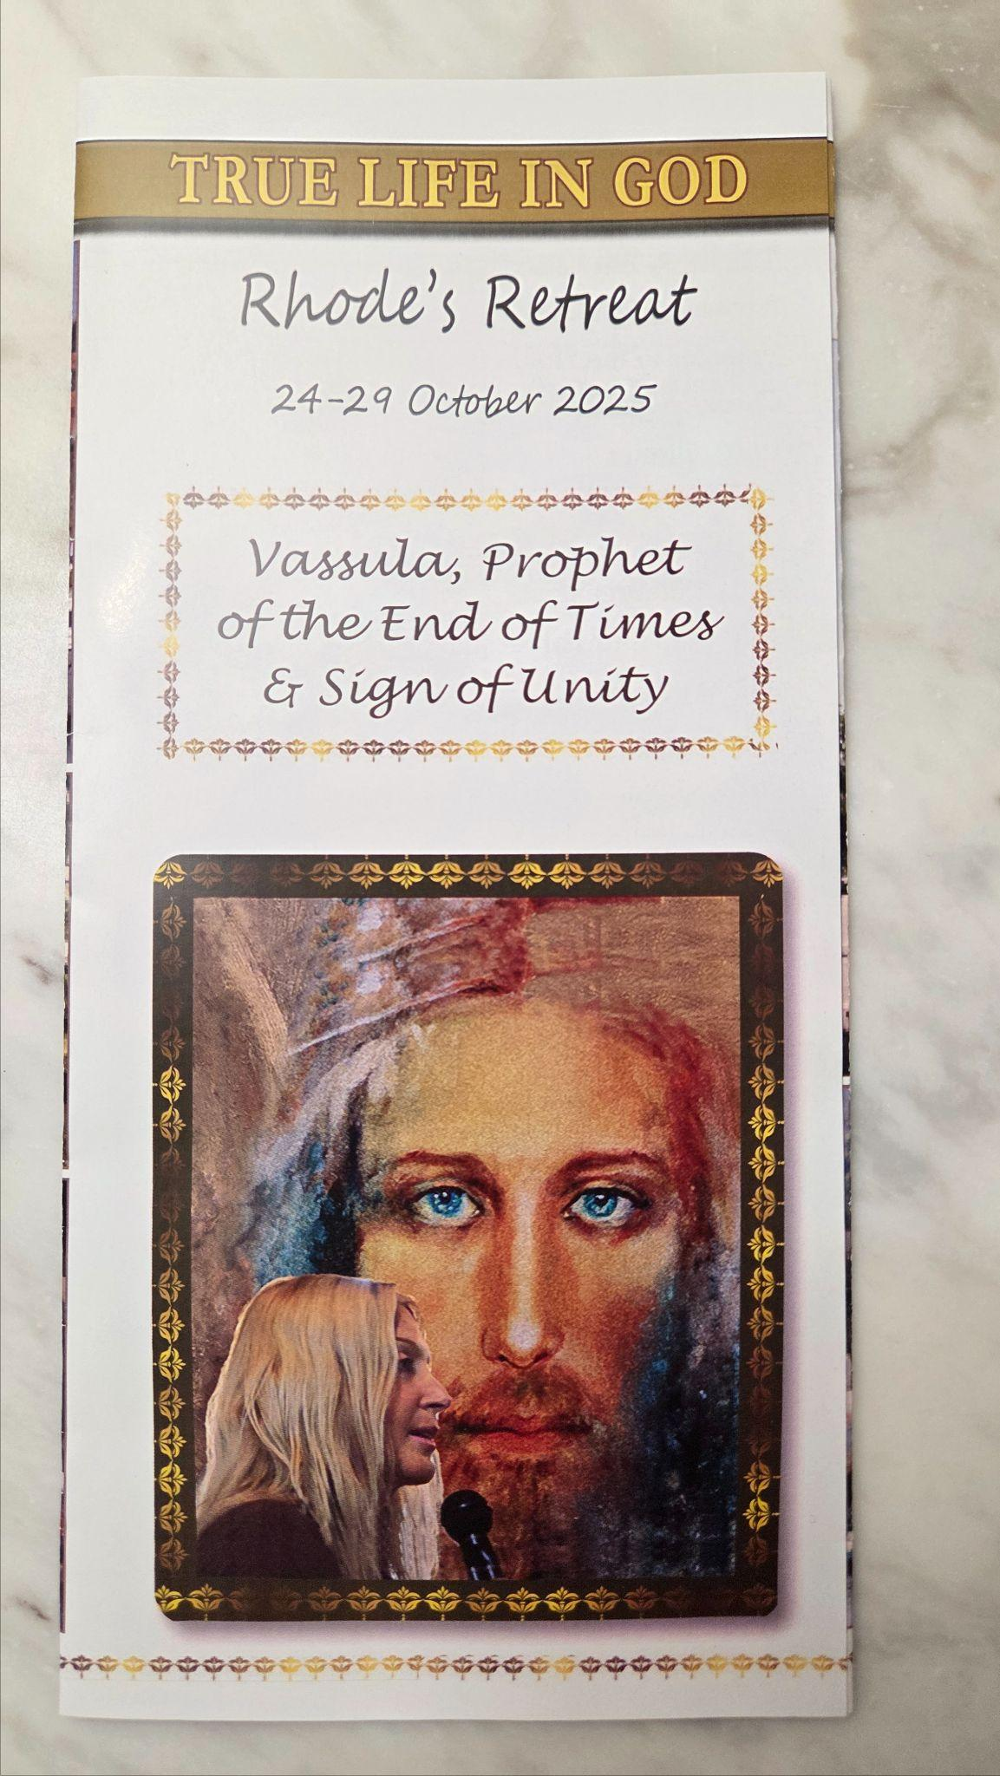

Report on the International Retreat in Rhodes,

October 24-29th 2025:

Vassula – Prophet of the End Times

The international retreat themed “Vassula – Prophet of the End Times, & Sign of Unity”, brought together participants from various parts of the world to reflect on Vassula Ryden’s prophetic writings and spiritual journey. The 5-day retreat was dedicated to celebrating Vassula’s life and spiritual legacy, as well as to encourage those who read and follow the messages of True Life in God. It is they who are called to be apostles of the end of times to evangelise with love for love
The Messages of True life in God (TLIG) are centred on calls for repentance, unity among Christians, uniting the dates for Easter and preparation for the end times, as foreseen in Christian eschatology. The retreat offered an opportunity to delve deeper into these themes, guided by the teachings and testimonies of these prodigious writings, which were shared through speeches from several invited clergy, along with other testimonies and informal discussions that took place throughout the period of the retreat.
The retreat provided a wonderful opportunity for both clergy and laity from around the globe who are involved in the apostolate of True Life in God to come together in unity, reflection, and thanksgiving for the profound impact Vassula made through her mission and for the messages of True Life in God given to us through God’s exuberant Love.
Hence, it was a celebration from beginning to end, and indeed at times it felt as if we were at a marriage ceremony where we were all guests at the main table with no differentiation regarding where we sat or who we are - just guests of the Divine Bridegroom and our garments were love and unity.
This report outlines the major events, highlights of discussions, and takeaways from the retreat, providing an overview for those who attended, and for interested readers who could not be present.

Background: The reason for the retreat in Rhodes.
Just over a year ago, the day after Vassula’s funeral in Rhodes, Greece, a small number of friends, as well as members of Vassula’s family, gathered at a small taverna garden at Afandou beach not far from where Vassula had lived with her husband Per for the last 17 years. Our gathering was, ostensibly, a reason to come together, whilst experiencing a shared sense of loss, in a spirit of solidarity to attempt to answer a question that sat with all of us, namely “What now”?
Sitting at that table in Afandou a year ago gave me a sense of what it must have been like for the apostles in the upper room as they gathered before The Holy Spirit breathed on them. To those of us gathered, there was a sense of bewilderment as we shared a deep sense of loss of a friend; and yet, almost as if waiting to be enlightened, we were all so aware of the call we all have: to continue with the mission of sharing this great Love Hymn from Heaven.
Despite experiencing this sense of numbness and unreality to Vassula’s loss, those present all firmly believed that the following year should be marked by a gathering in Rhodes, bringing those deeply touched through the messages of True life in God together to celebrate Vassula’s life. All of us were aware that in the message of June 12 2020, The Lord said,
“My Royal Sceptre of Virtue will lead with kindness anyone who will be willing to walk with Me in this narrow path; anyone who will be willing to cry out: “here I am Lord! I am willing to obey Your Will;” This was a decision made with the realisation of the promise also in this same message,” full you shall be many” understanding that “The Holy Spirit who encompasses everything without measure will breathe in you and move in you;”
And so, an agreement was made then that the Greek TLIG Association particularly those in the TLIG Rhodes prayer group would head the plans for a retreat, as Vassula was particularly close to them, and they were familiar with many of the places and prayerful practices that Vassula liked to share with others.
In Spring of 2025, the announcement went out to all the associations that the retreat would take place from the 24th until the 29th of October, just over a year after Vassula returned to her true Home, and it would be in her loving memory. It is the first TLIG gathering that has ever been organised and held without her guidance. While she was still with us, she constantly encouraged those closely around her to learn how to do things without her, as she said, “When I am no longer here with you all.”

Structure of the Retreat
There were 30 different countries represented and clergy from five different denominations namely Roman Catholic, Greek Catholic Melkite, Ukrainian Orthodox, Greek Orthodox and Lutheran.
The retreat was structured over several days, featuring keynote talks, the celebration of mass, reflections, prayer sessions, and opportunities for visiting sites in Rhodes that reflected much of Vassula’s life on this island and surrounding areas. The schedule allowed participants to engage spiritually and intellectually, fostering an environment of contemplation, dialogue, thanksgiving, praise, worship and renewal. Several speeches and testimonies addressed the life and legacy of Vassula and the prophetic call she had.
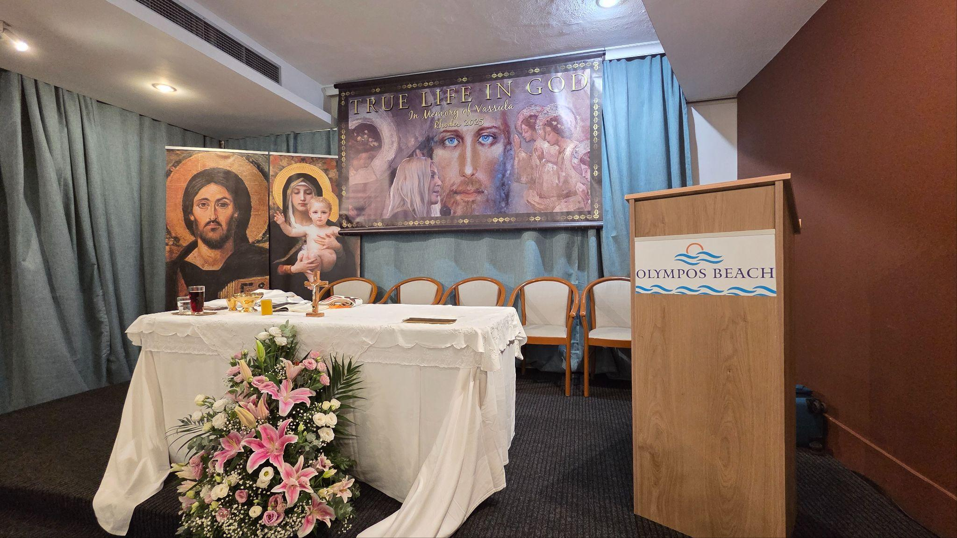
The altar inside the hall at the retreat venue

Key Themes and Speeches over the course of the retreat

- Unity of Christians: A significant portion of the retreat explored the theme of Christian unity, echoing Vassula’s call (as an echo of The Lord) for the healing of divisions within the Church. Participants engaged in ecumenical prayers and discussions, seeking practical ways to embody unity in their communities. Archbishop Jeremiah Ferens highlighted in his speech about the restlessness of the society in which we live, and the global context in which Vassula “was sent to prophesy” which was compounded by divisions amongst Christians. He concluded a marvellous speech by stating that the truer our life in God is, the more capable we will be towards promoting peace, unity, and a human and spiritual well-being in the world.

- A prophet for the End Times: Drawing from scriptural references in various testimonies, speeches and Vassula’s own experiences, the retreat examined signs associated with the end times, encouraging vigilance, prayer, and trust in God’s providence. In several speeches there were stark reminders that for almost 40 years, through Vassula, God has been offering us the opportunity to approach Him and get to know Him intimately, having a true understanding of Him in His Trinitarian Holiness, and for our personal conversion. Through Vassula’s prophetic voice conveying the messages of True life in God, we have been warned that through our apostasy this world is on a path to self-destruction.

- Divine Nuptials in the TLIG messages – a reminder of the theme that runs through sacred scriptures and the messages of TLIG is the invitation to the abandoning of one’s will to God, allowing our souls to become God’s spouses.

- Celebration of a jubilee year – Fr. Anwar El Khoury delivered a beautiful homily on the invitation of all pilgrims of hope to encounter the mercy, freedom and hope that flow from God’s Love. He shared that Jesus is the living Jubilee. In Him, every heart finds rest; every sinner finds a home. In Him, debts are forgiven, relationships healed, and peace restored. Although we belong to different Christian traditions, the Jubilee belongs to all of us.

- Personal Conversion and Holiness: Emphasis was placed on the need for ongoing personal conversion, fostering a life of holiness, humility, and service. Testimonies from participants highlighted transformative experiences resulting from both meeting Vassula and upon reading and living the messages.

- Thanksgiving- the whole of the retreat was flavoured with this theme, for this great Love Hymn and His Messenger, Vassula. It highlighted too the responsibility that rests on each one of us to make others aware of God’s love and mercy that He has for each one of us. At the end of several of the days and particularly the last day, the now well-known Greek hymn of praise Doxa Doxa Sto Theo, was blasted out from international lungs in the hall of the Olympas Hotel.
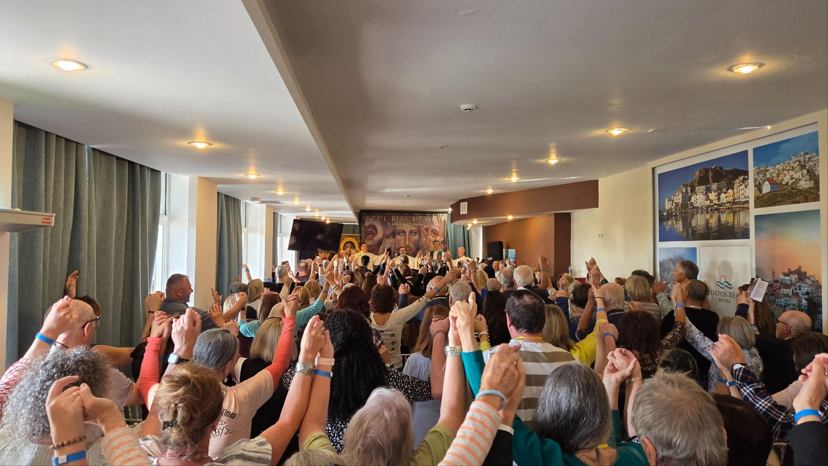
The retreatants singing Doxa Doxa together in thanksgiving

Walking through the days of the retreat

Day 1

The official arrival date for the retreat was 24 October, although many retreatants had started to arrive one or two days before this, as some had travelled from countries as far off as Australia, Philippines, USA, South America and Africa.

Rhodes is a beautiful island and one which was still enjoying, at this time of the year, very pleasant temperatures and sunshine for most of the day. There were many Europeans, and others from northern countries who were all too keen to experience the beautiful weather that we had been granted for the duration of this retreat.

The retreat was hosted in the Olympos Hotel, set along Faliraki beach on the Aegean Sea. It provided us all with comfortable accommodation, a meeting hall where the Masses and talks were held, and a huge dining room, which in true Greek style had tables groaning with the amount and variety of food. The large area for dining allowed the whole TLIG family, at allocated times, to be able to spend time eating and talking together as breaks in between the programme were considered and generous. This seemed to have been appreciated by many who attended. People have stated at previous pilgrimages and retreats that it is important to have the time to spend with other people in True Life in God from all the various countries who attend and whom they see only at these gatherings.

The noise in the dining room whenever we were all together, as well as in the special meeting room where we had for the duration of the retreat, reinforced the sense of a gathering at a wedding feast. It reminded several of us of occasions when Vassula would say in her demure way and yet with a twinkle in her eye at similar gatherings, “You don’t fast when the Bridegroom is here” when some of us would be commenting on how much food there was and that we would need to abstain when we returned to our respective homes. She knew only too well of the sense of gathering and celebration that there invariably is and was at these retreats and pilgrimages. Yet, this was more than the physical food at a wedding feast. The excitement, the expectation, juxtaposed with the collective quiet that would fall when led in prayer and worship with the celebration of Holy Mass and Divine liturgy, provided us all with a sense of having been invited indeed to a very special event, when, just as if at a wedding, after the feasting, it was time for the speeches, sharing and reflection. Our hearts were filled with joy and a tangible love that seemed to permeate through the meeting hall and areas of the hotel where we gathered. It was indeed an invitation to take a retreat in Him and be with the Bridegroom.
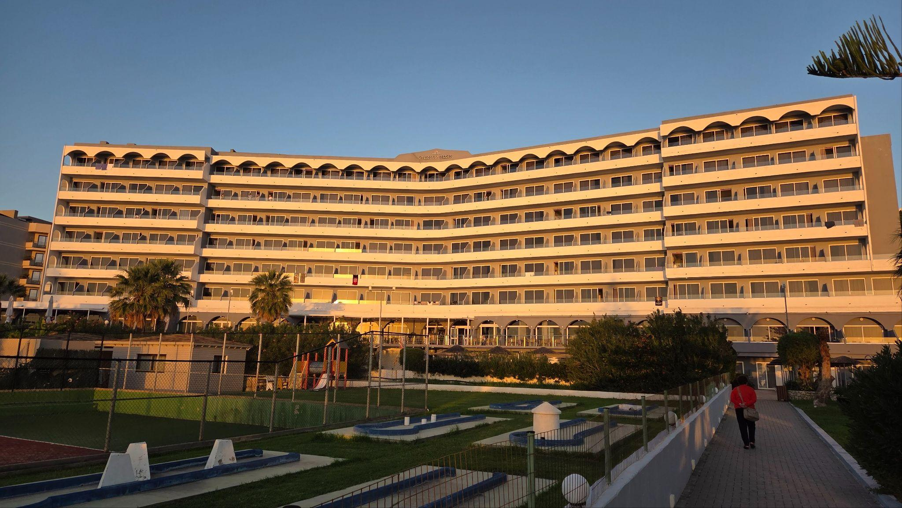
Hotel Olympus - retreat venue
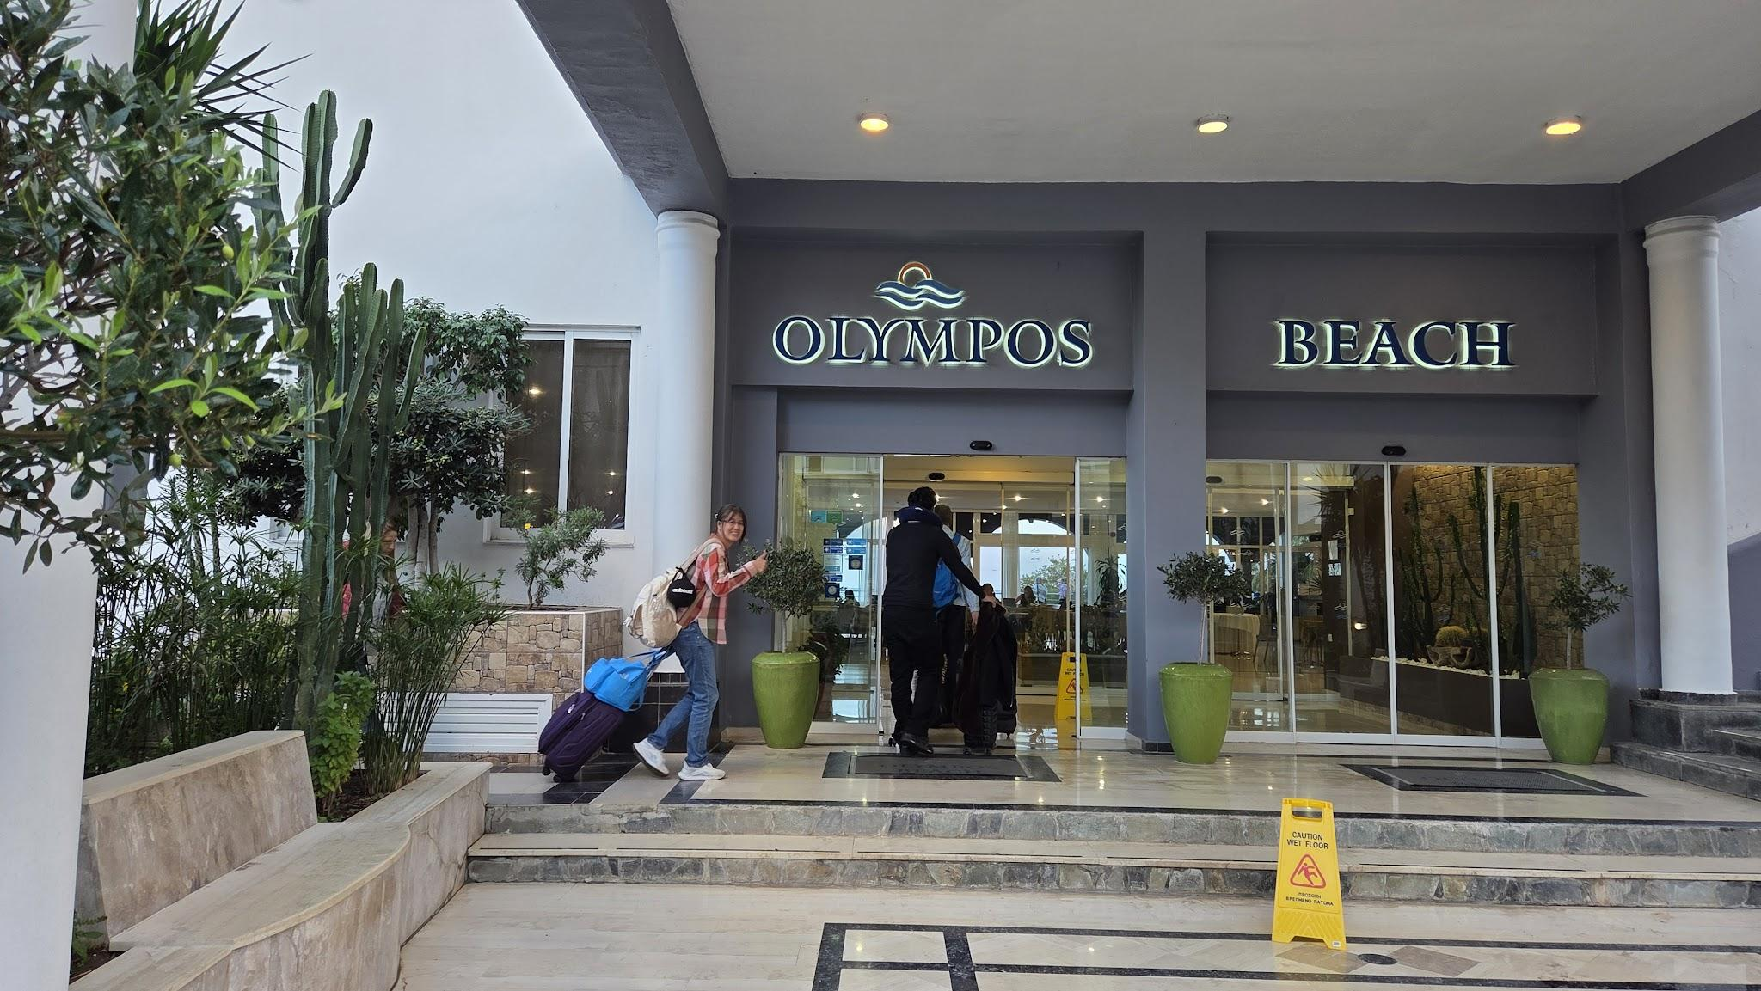
Arrivals day at the Olympos beach hotel, Rhodes

Day 2
Saturday 25th October commenced with everyone gathering in the meeting hall assigned to us for the duration of the retreat and to sing the Our Father in Aramaic. Many people in the True life in God apostolate are familiar with the words to this beautiful prayer and can sing along, as it was also printed in the small prayer group guidelines which many participants accessed.
A warm welcome was extended to everyone by Theodora Konidari from the Greek Association of True Life in God who is also currently the secretary for the International TLIG foundation. In her welcoming speech, Theodora reminded us of Vassula when she used to tell people who attended the TLIG retreat and pilgrimages that we were not there by chance but that we all had a calling. Theodora requested permission to say that we had been brought to the retreat to continue Vassula’s legacy and spread the messages of True life in God throughout the world; none of us were there by chance.

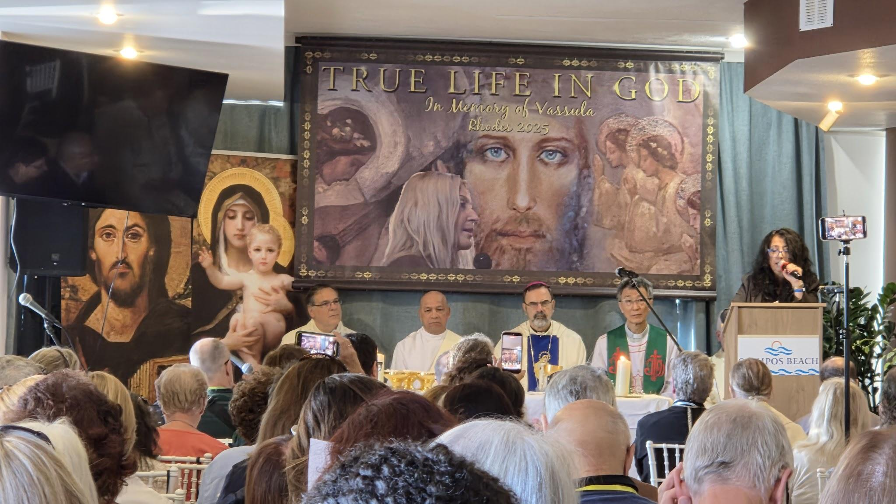
Welcome speech from Theodora Konidari
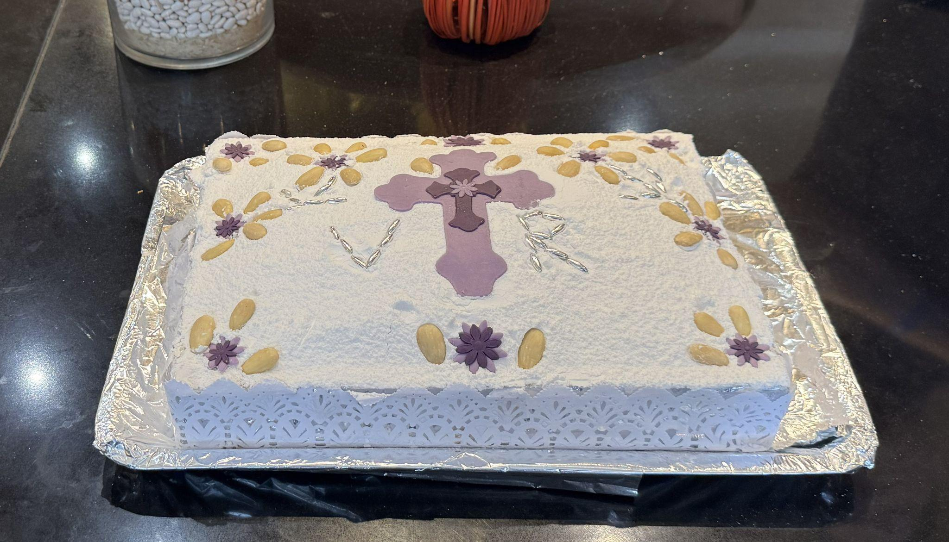
Immediately afterwards Archbishop Theodore Kontidis celebrated Mass which was duly followed by a memorial service for Vassula and conducted by Fr Vasilis Michelakis. A short video of Vassula was shown which had such a profound impact; many people commented on the fact that it was as if she were in the room with us at that moment. We were then all given a small tub containing Koliva. Koliva is a sweet offering, used in the Greek Orthodox church for the commemoration of the departed. It is blessed by a priest, (for this occasion by Fr Vasilis) and then shared among the mourners to remember and pray for the deceased. It is a ceremonial dish of boiled wheat, sugar, and spices and it symbolises death and resurrection, as the wheat represents the cycle of planting, dying, and new life. The sweet ingredients, such as sugar and raisins, represent the sweetness of Paradise and the hope of a peaceful afterlife.
Photo of the Koliva before it is distributed as individual portions..

Seamlessly, the memorial service led into two short speeches by the clergy, namely Archbishop Theodore, who chose to highlight some of the messages of True Life in God that are important to him. Archbishop Theodore focused on the keys to Christian unity, namely love and humility, and touched on the challenges Christians have in relation to addressing traditions, as well as a call of an awareness of the sin of pride; where and how this awareness can exist through the love that we are called to share from Christ in the gospels. This speech was followed by Fr Vincent Cosatti’s and his experience in knowing Vassula and the messages of True Life in God.

After our lunch break, we all boarded one of the four buses that awaited us, each holding a capacity of 50 people with an allocated bus captain. Two buses departed to take retreatants to the local cemetery: to Vassula’s graveside, whilst another two buses departed to visit Vassula’s residence at Afandou and one her favourite places in Rhodes, Panagia Tsampika, which is a revered monastery with a miraculous icon of the Virgin Mary. This schedule was then reversed so that at the end of the day each bus had visited the graveside, Vassula’s residence and the monastery of Tsambika.
At the graveside there were special prayers recited by Archbishop Jeremy Ferens as well as Fr Julio Gaddi. The mood was sombre and prayerful and many present held flowers in their hands. Upon visiting the graveside, they respectfully left the flowers in vases around the grave, walking away quietly and meditatively. The visit to Vassula’s residence held a similar solemnity to it. The TLIG foundation has purchased the residence in order that it may be visited in the future as a holy site where many of the writings within the full volume of TLIG were received. The local prayer group gathered here. For many of us present at that moment, standing in the shade of her garden, there was a flood of beautiful memories of having tasted Vassula’s hospitality whenever visiting Rhodes and staying with her or receiving hospitality from her. Each person present was offered that fitting hospitality being given a small, sweet treat and a drink in the garden. We were all shown around the house in a respectful and dignified manner, after which we either made our way onward to the monastery of Tsambika or returned to the hotel having visited the monastery already.
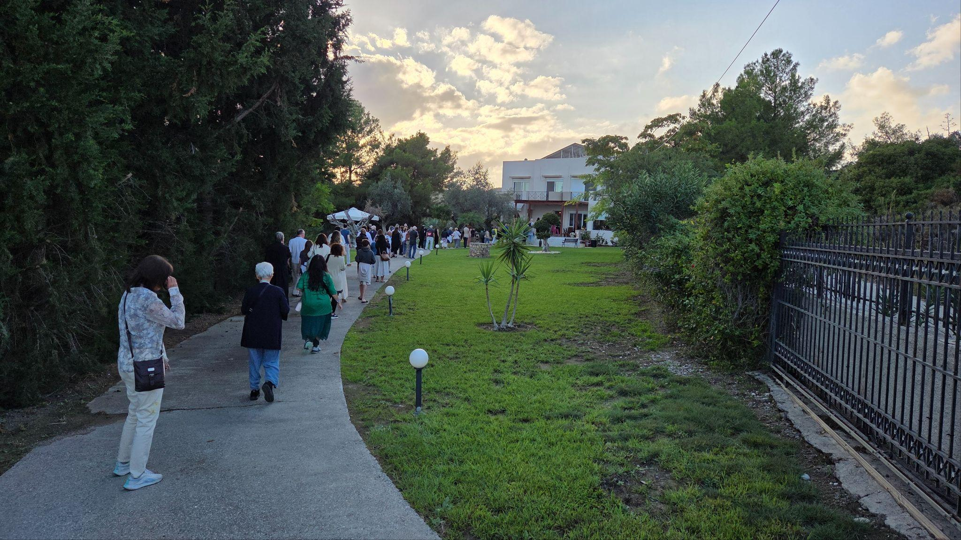
Some of the groups arriving at the residence of Vassula
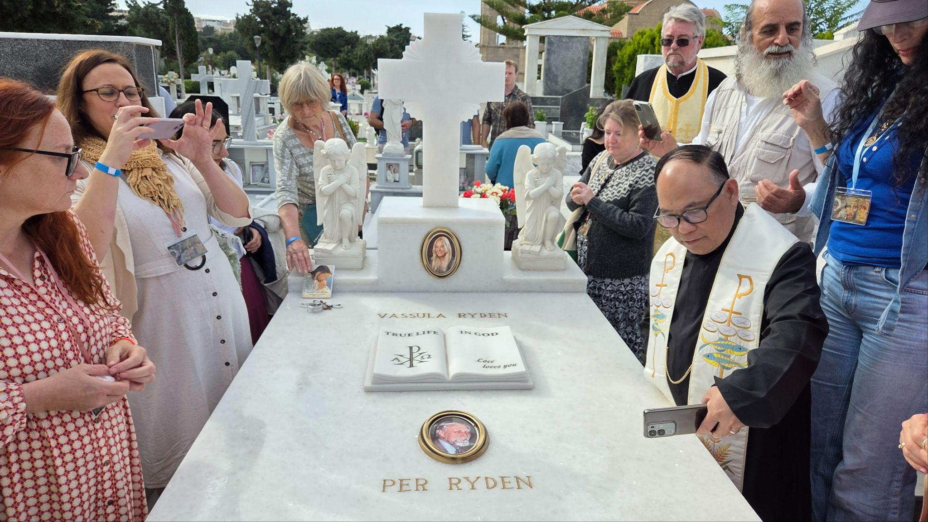
At Vassula’s graveside
The day concluded with an air of earnestness and gratitude. Following dinner, we convened to conclude the day with a short video and the recitation of the Rosary.
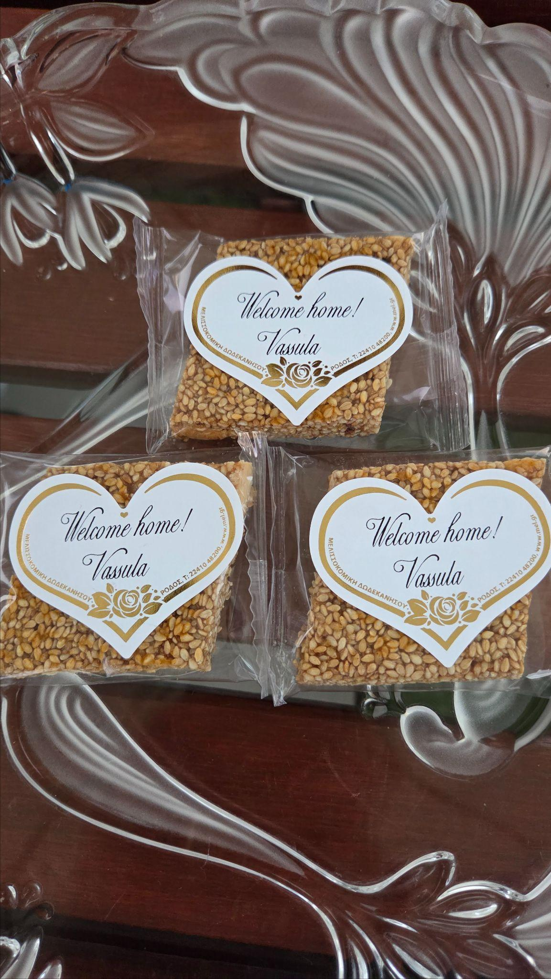The small sweet refreshment offered to everyone at Vassula’s residence

Day 3

Sunday 26th October
The day started as usual with Our Father in Aramaic, followed by Holy Mass celebrated by Fr Joseph Ianuzzi and at which Father Otfried Chan provided a pertinent and powerful homily.
In his homily Fr Otfried challenged those present to consider how we, as TLIG readers, should respond to God’s merciful call and promote unity with God and with others by bearing witness to the merciful love and forgiveness we have received and are still receiving from God. He emphasised that our conversion must be on-going and we must continuously renew our commitment to the Church, no matter what sacrifices it may imply. His homily reminded me of one of the last pieces of advice that Vassula left all of us, namely, that there should be no competition amongst us and that we must always encourage one another.
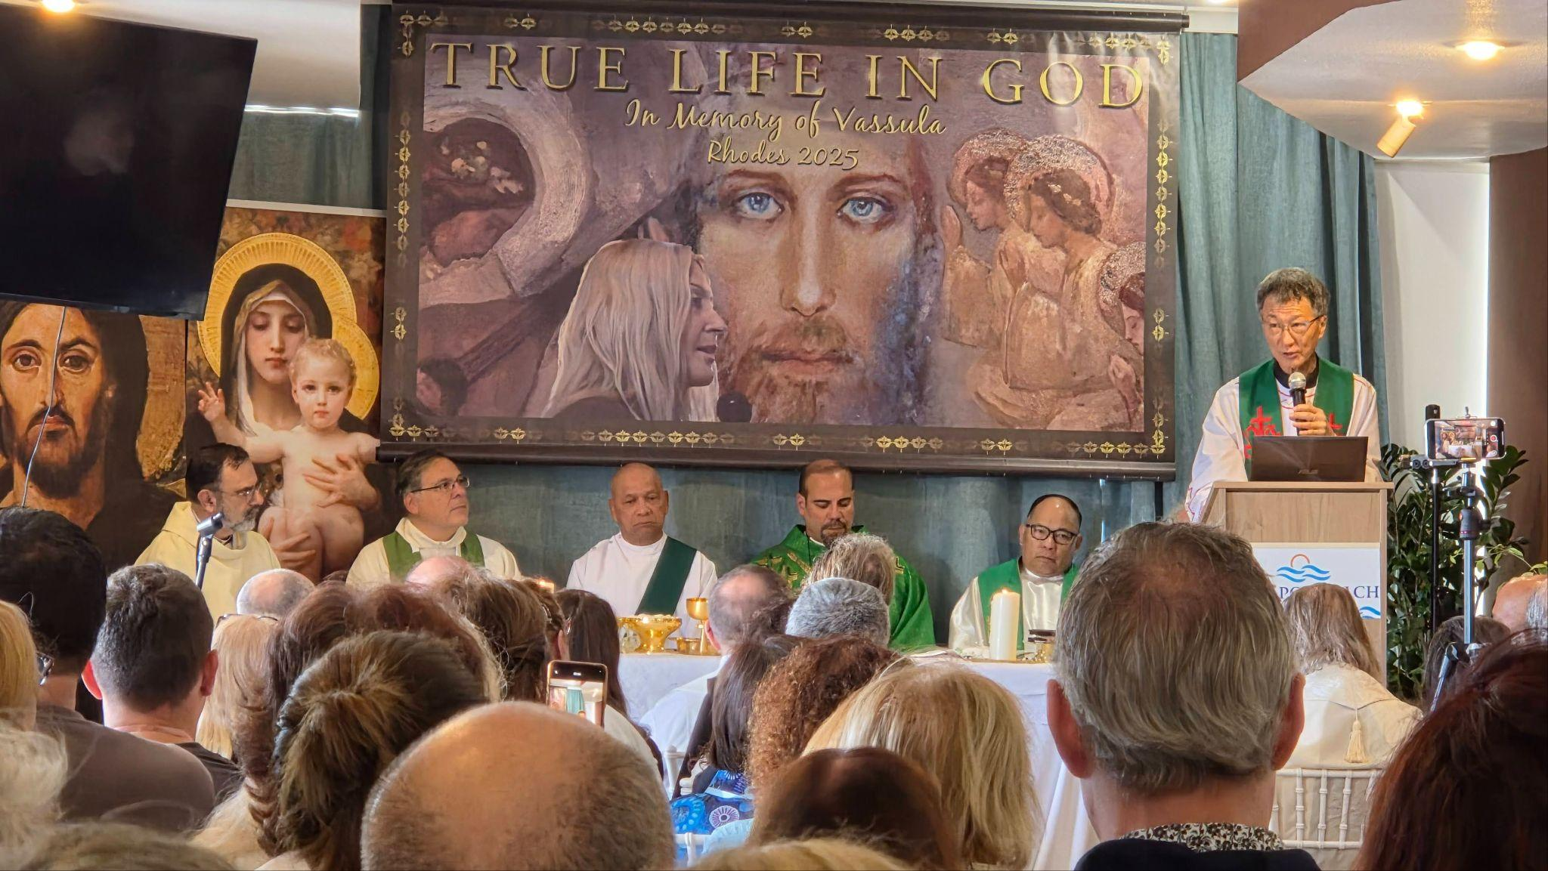
Fr Otfried Chan giving the homily on Sunday 26th October 2025
Whilst still maintaining a sense of being at a wedding feast, rather fittingly, after a short break, Fr Ianuzzi delivered a speech focused on the Divine nuptials where he shared that in the True Life on God messages, “we encounter an exponentially increasing emphasis on the importance of nuptials.” Fr Ianuzzi continued by saying that this is due to God’s desire to espouse us, the members of his body “as a bride adorned for her husband” or as the “spouse of the Lamb” and in a manner described by St Paul in Holy Scriptures (Eph. 5:27). He elaborated by saying that this divine wedding feast cannot take place unless it has begun on earth. He quoted from the True life in God message of February 3, 2003 where the Father speaks and tells us that,
“You will be dressed in glorious perfection, ready to go up to the holy altar to meet your Bridegroom, where Divine Grace will lead you to be... I will grant you then, My own, the sight of My Divine Face; although you will still be on earth, you will be in Me...
your King, overflowing with Love, will lean forward towards His bride and will hold gently her head, reposing it on His Bosom, saying in a melodious Voice these words to you: “Now I am holding you fast;” while a ray of radiant light would stream out of My Mouth and cover you...
“I am giving Myself to you to possess Me and discover Me within your heart, My own; discover Me in My transcendent Light and you will shine on every one of your members like Moses’ face shone upon seeing Me face to face; come forward and I will shine on each one of your members;” the Nuptial Chamber where I lead every soul to take part in My Mystical Marriage;”
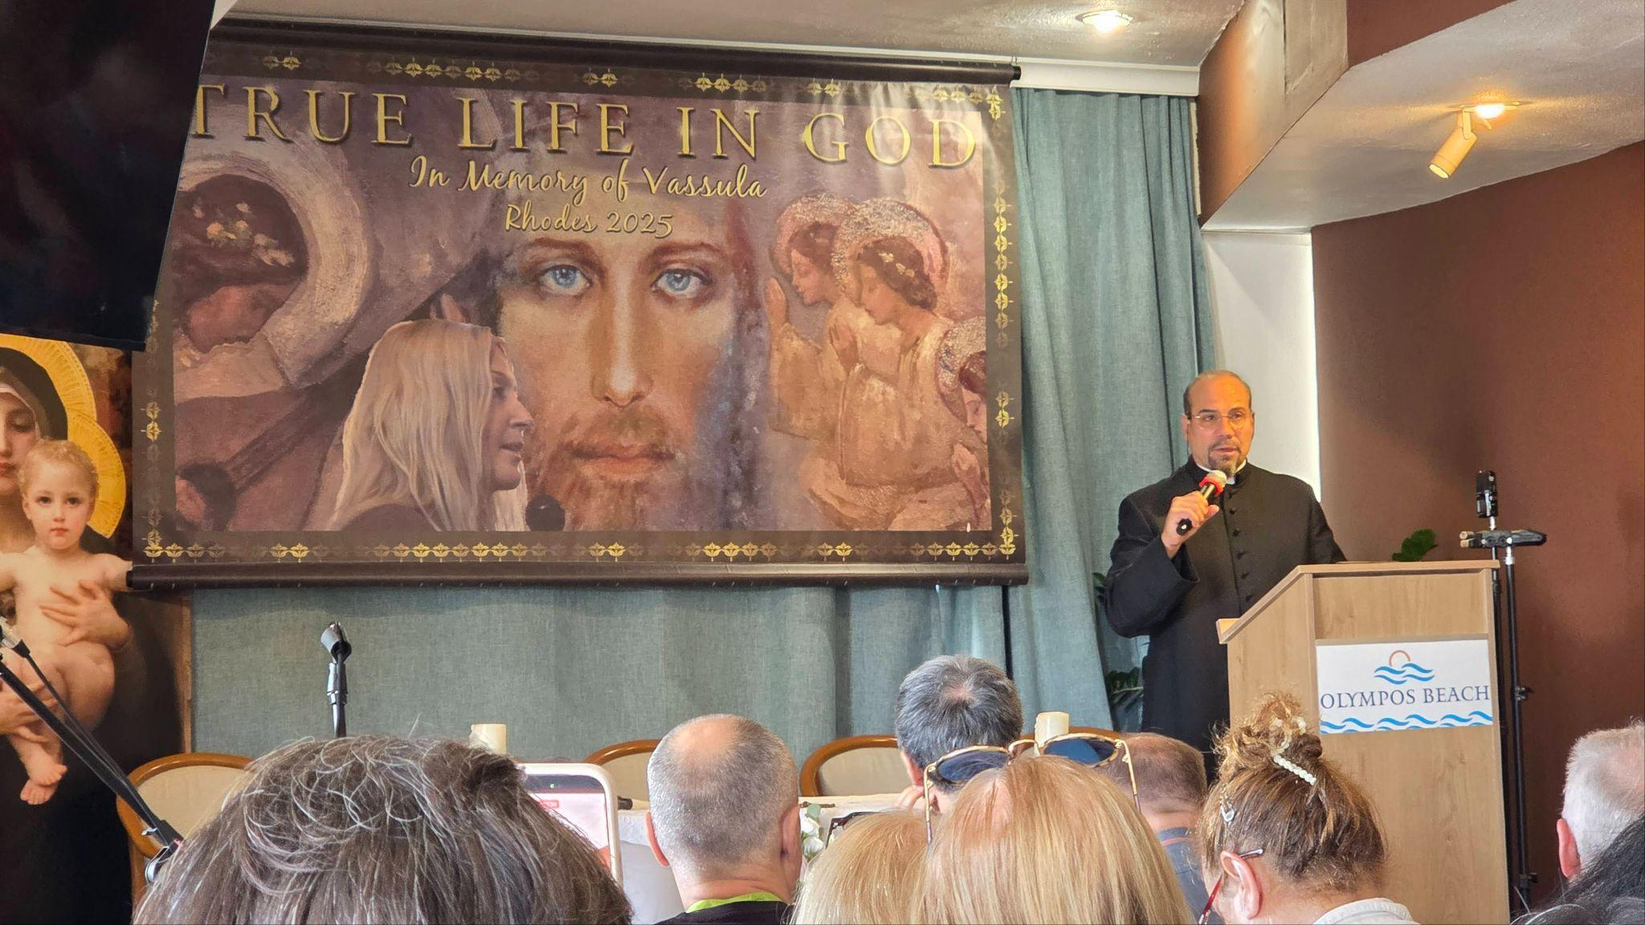
Fr Joseph Ianuzzi delivering his talk on Divine Nuptials and TLIG
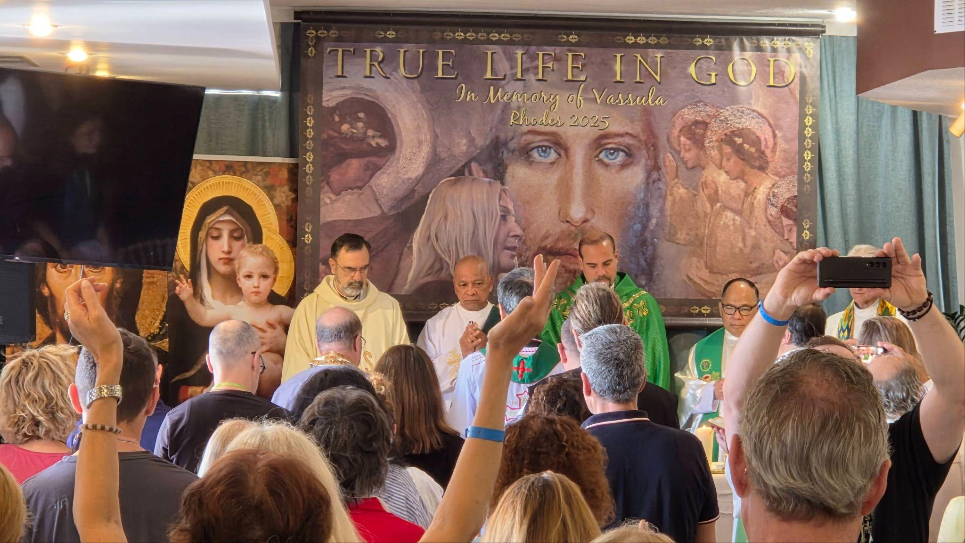
Celebrating Mass on Sunday 26th October
Following this beautiful speech, two lay witnesses were invited to share their knowledge of Vassula and the prophetic mission. Carol Chamberlain from Scotland shared as well as Maria Corazon Zaballa from the Philippines; this was followed by a short video on Vassula and Unity.

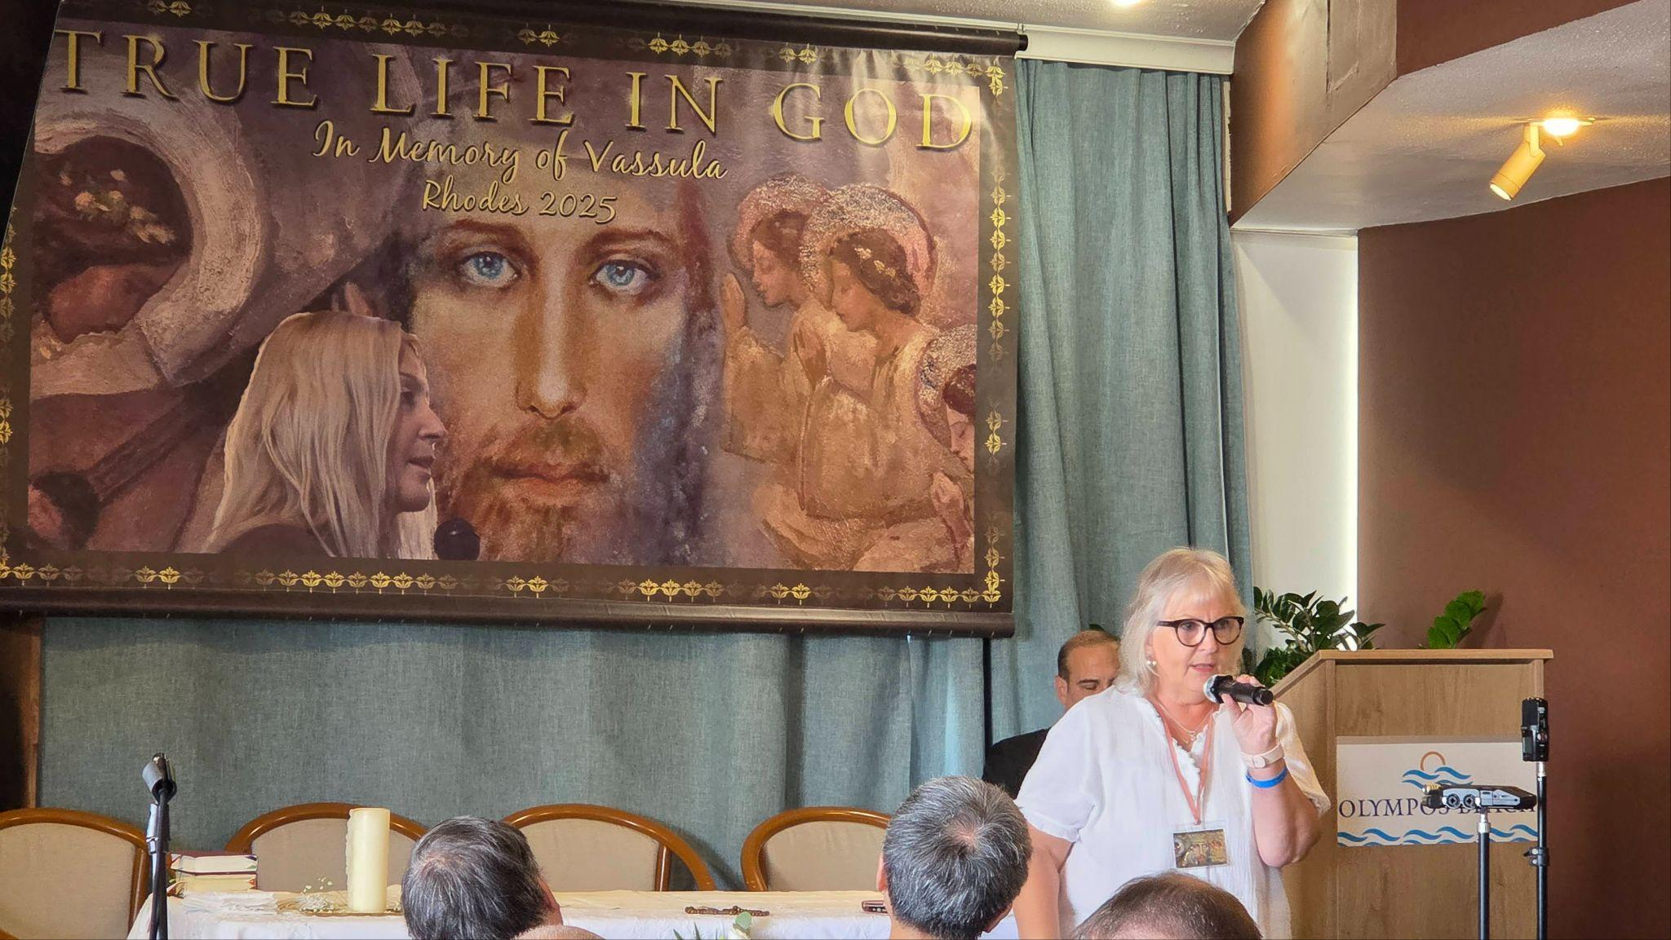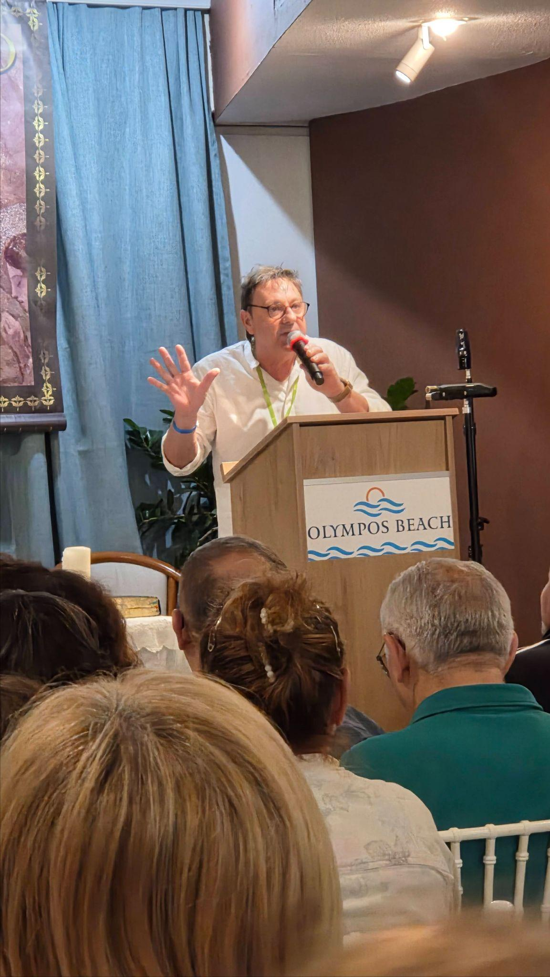
A collection of some of the lay testimonies over the course of the retreat

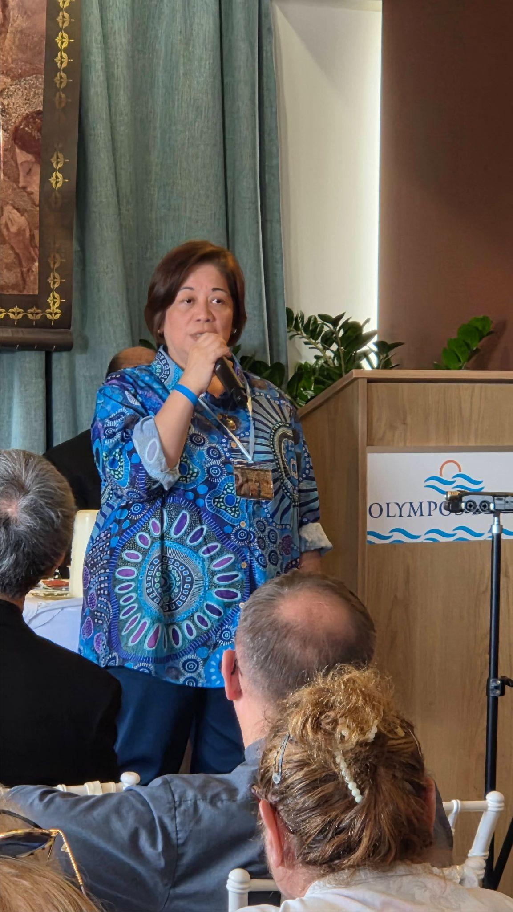
Fr John Corbett from USA delivered a fourth speech with the emphasis on an ontological shift (a fundamental change in how one understands the nature of reality, existence, or being) that we are experiencing, pronounced through Vassula and the prophetic writings of True Life in God.
Fr John shared that when he thinks of Vassula he remembers a female version of John the Baptist in our era. He explained that both John the Baptist and Vassula had prophetically preached at the end of their respective eras: "The Kingdom of God is at Hand." Fr John reinforced the need for us to exercise caution and to keep a strong focus on The Holy Spirit whose era has re-begun in True Life in God. His teaching through his speech is that our God given mission in TLIG is not easy, as we are challenged by evil forces constantly because of our witnessing to the world and to the church itself; but, in witnessing, a True Unity in and through the Holy Spirit is brought about.
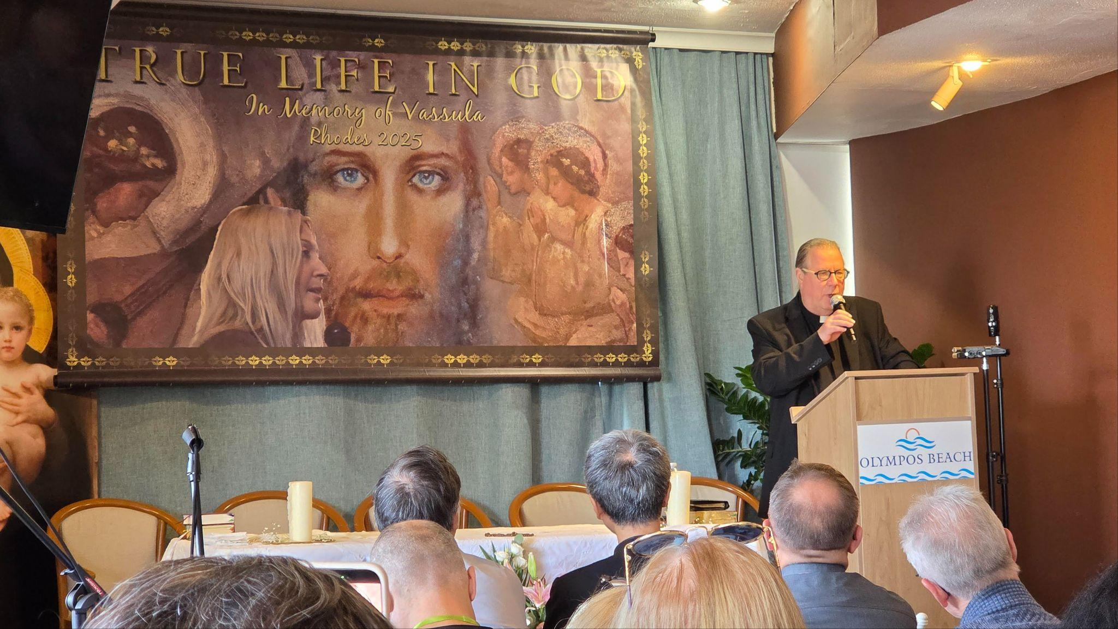
Fr John Corbett speaking on Vassula as a prophet of the end times

Prior to breaking for lunch, the whole room worshipped in hymns of praise. We received an invitation to partake in the Sacrament of Reconciliation/confession as well as enjoy some wonderful free time, which many people did, either by going for a fresh swim in the sea or sharing in the many activities available in the surrounding area.
The evening settled in, and another speech was given: this time by Archbishop Jeremiah Ferens of the Ukrainian Orthodox Eparchy in South America. Archbishop Jeremiah spoke to us about how for almost 40 years, through Vassula, God has been trying to awaken, in all humanity, a true understanding and conversion, reminding us of many things that were said in the past through Holy Scriptures by the Holy Prophets and in His own Commandments. He shared that through Vassula God is calling us to make peace with Him, not to rebel against Him. Through a persistent apostasy, the world is in danger of self-destruction. He continued to say that we know the messages of TLIG are a call to reconciliation, to the practice of charity and to unity. He spoke of Vassula as being a symbol of unity. She had the appeal to unity as her main subject stating that, “The prophetess persistently sought the unity of Christians of all denominations through the messages received from Jesus Christ. She herself stated that such unity is a core message of True Life in God.”
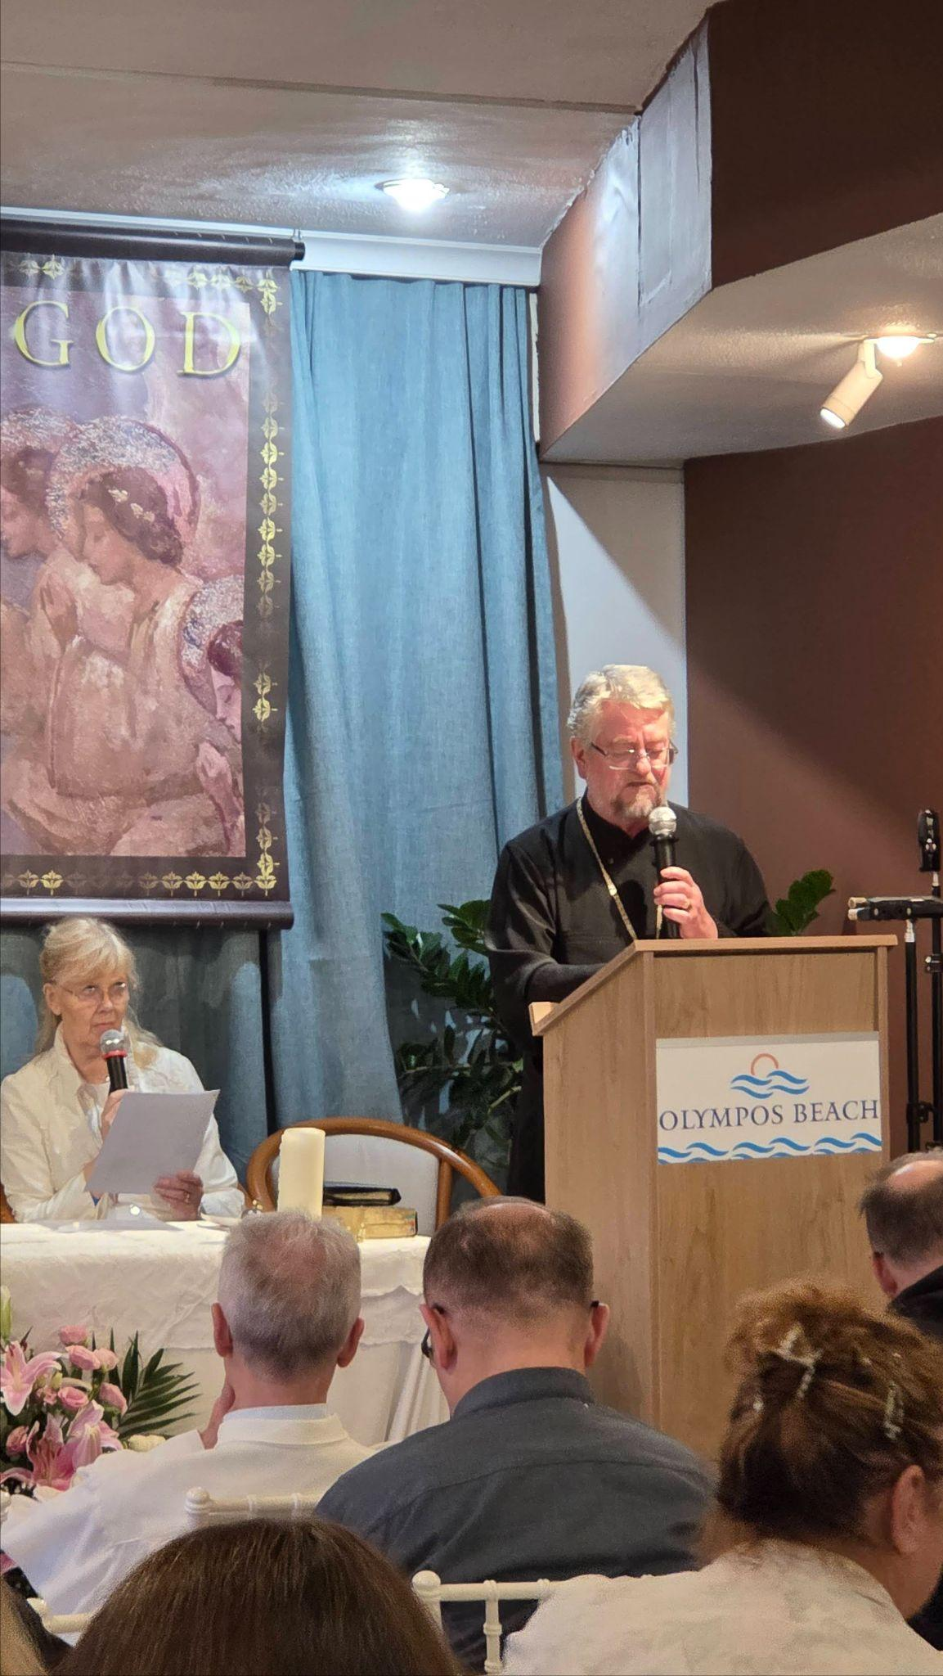
Archbishop Jeremiah Ferens witnessing to the prophetic call of Vassula
This speech was followed by more powerful testimonies from laity namely Cornelia Rebholz from Switzerland and Erwin Schlacher from Austria, unique in their content and delivery, reinforcing the power of God’s love and Mercy in knowing the messages and having met Vassula.
The evening concluded with a beautiful rosary and healing service where the clergy who were present invited all those attending to come forward for a blessing. The sense of peace and the Healing love of God was tangible. Many people were visibly touched by the healing that took place. Following dinner that evening, there was adoration of the Blessed Sacrament before concluding for the day.

Day 4
Monday 27 October saw everyone up bright and early and Holy Mass was celebrated prior to everyone gathering at 9 am promptly to embark on four buses for Mandraki in Rhodes town. There, a boat was awaiting to take all of us over to the island of Simi and a visit to the monastery in the village of Panormitis. The village of Panormitis, located southwest from the main town, hosts the main monastery of Simi Island, a monastery dedicated to the Archangel Michael.
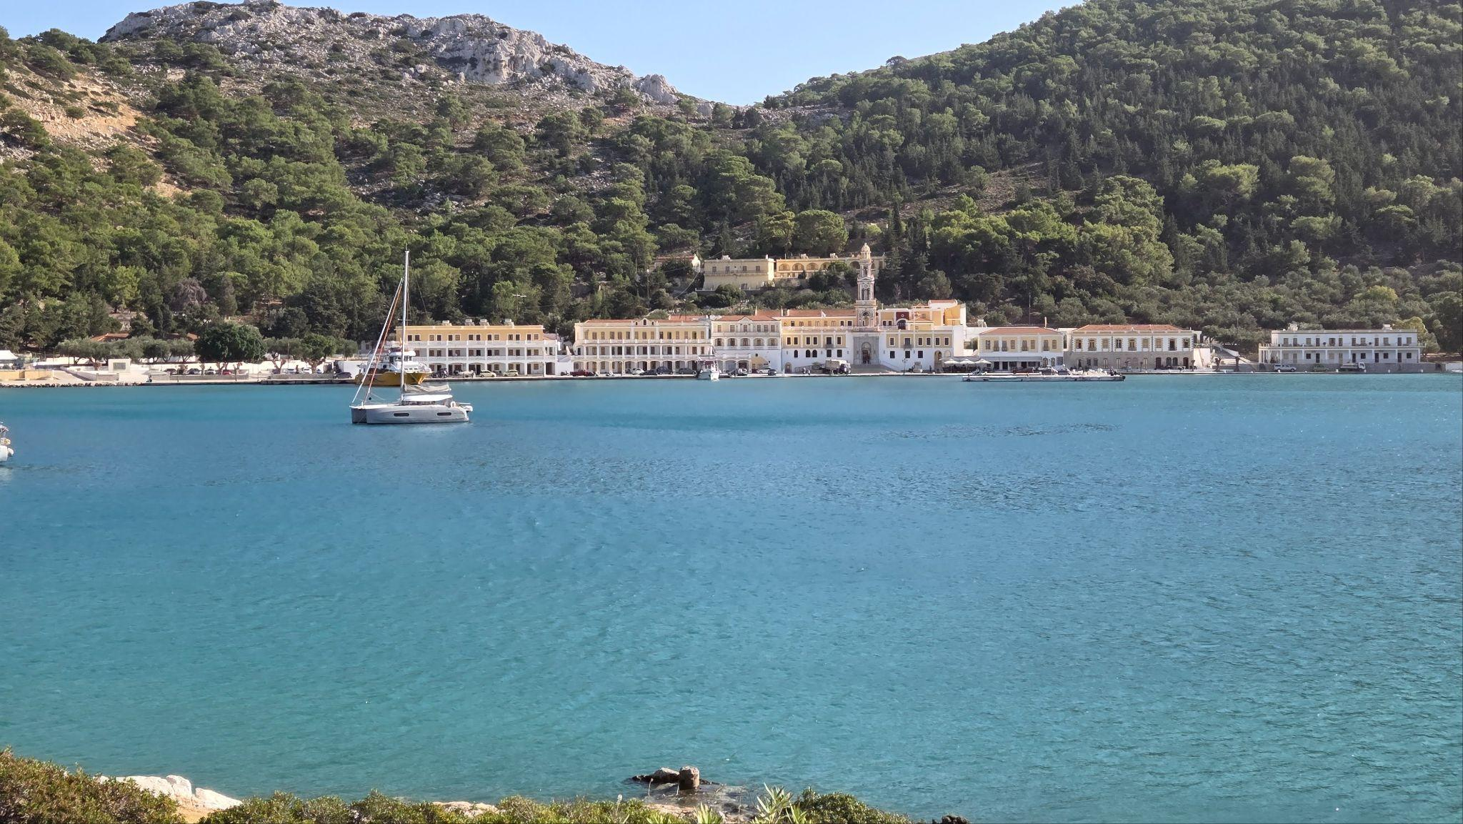
The view of the monastery in Panormitis
Vassula had a particular fondness for visiting the monastery at Panormitis and its surroundings. She would regularly suggest to those in the Rhodes prayer group, who remained very close to her, to join her for a few days or a long weekend in fasting on bread and water and pray with her. She would invite them to listen to her words, as she would always prepare a theme for their retreats through the messages.
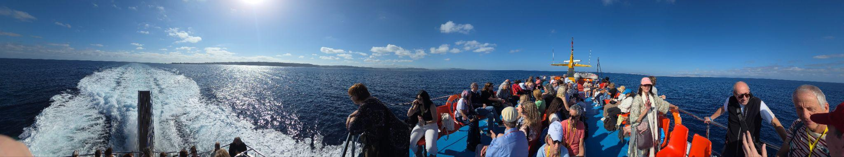
The boat journey from Rhodes to Panormiti
The journey from Rhodes, northwest to Simi is just over an hour. Mostly everybody was glad to see the curve of the rocks on shore and the cove appear to reveal Panormitis and the dominating monastery sitting almost at the water’s edge. The monastery is located on the south end of Symi, situated on the seafront of the tiny village of Panormitis. It is a closed-in cove with a small sandy beach, protected by a narrow inlet that opens out into a wide harbour. The mountainous backdrop is covered with pine trees which give the area an ambiance of solitude.
Once in the church of the monastery everyone had the opportunity to visit the famous miraculous icon of the Archangel Michael Panormitis, who is not only considered the island's patron saint, but also the guardian of sailors in the entire Dodecanese area.
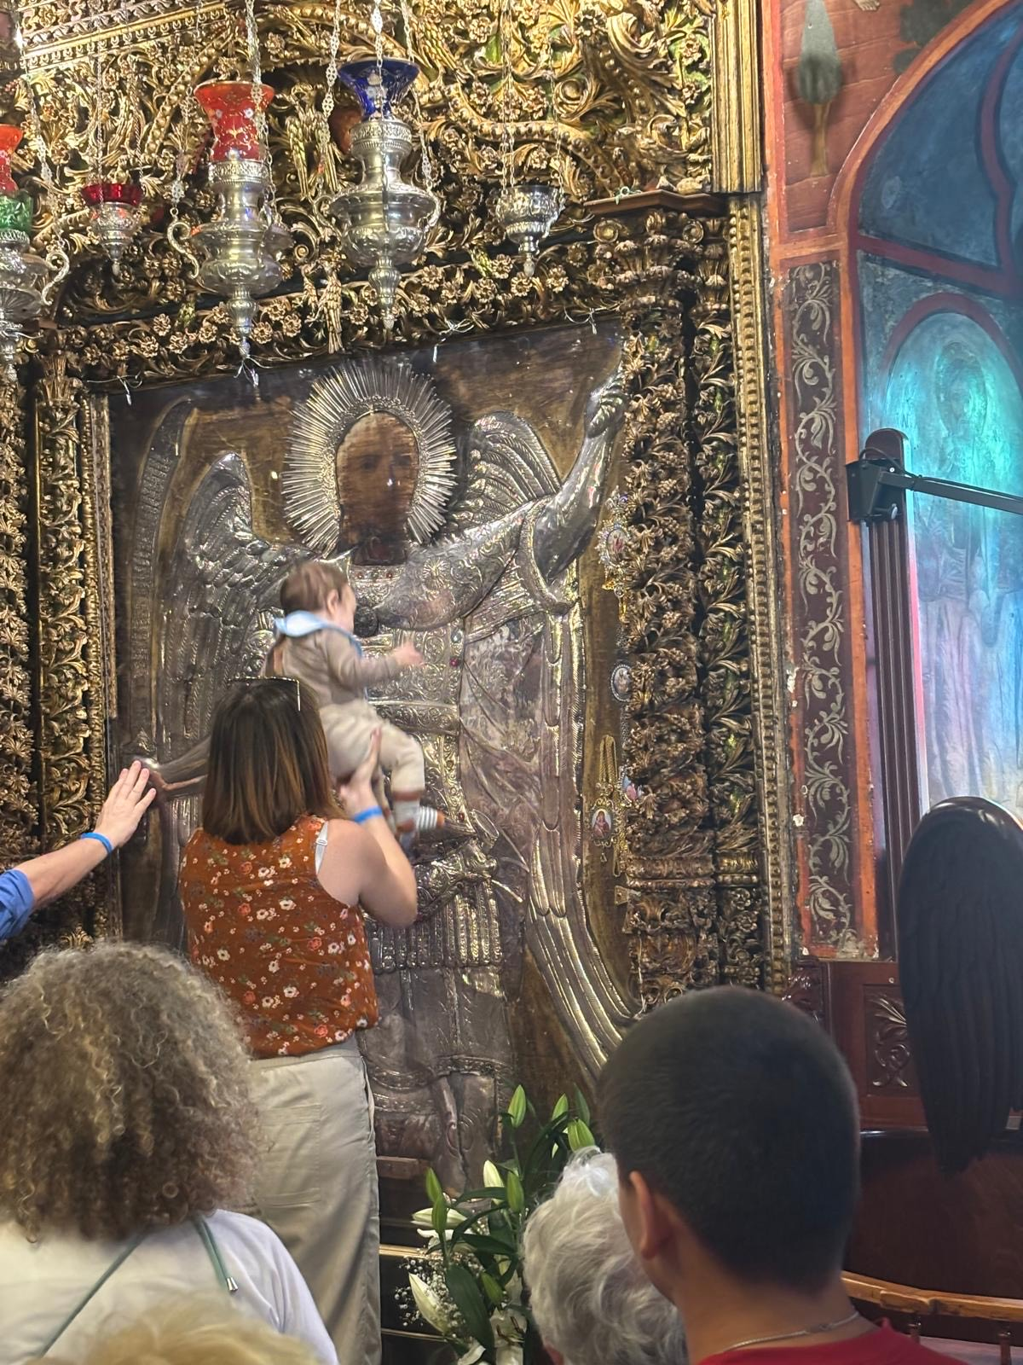
Photos of the miraculous icon of St Michael inside the monastery and people waiting to see the icon
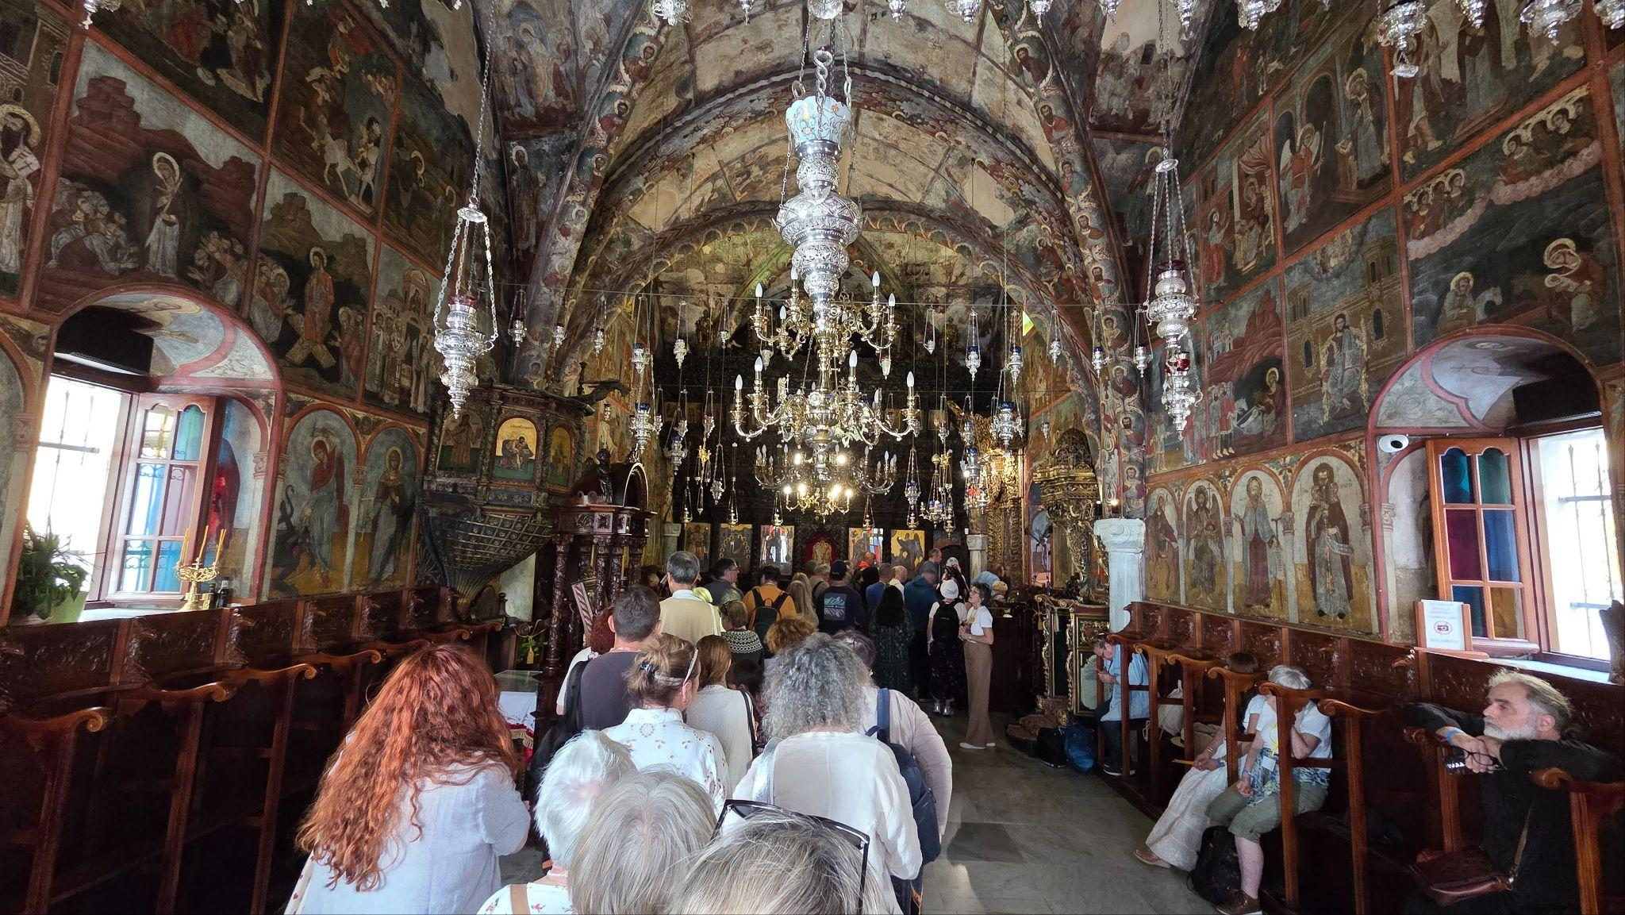
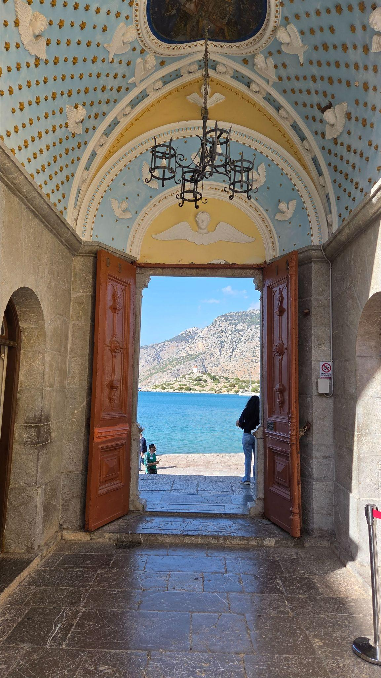
One story is that this icon appeared miraculously, and, on several occasions, was removed only to reappear mysteriously in this same location. The church was then built over this location, which, other sources suggest, was also a template to Apollo.

In the early afternoon, everyone was invited to walk around the cove over to an area called Mylos, easily recognisable by a prominent small white windmill on a rocky hill that overlooked the monastery on the other side of the cove. This was a more sombre and moving part of the retreat as we all gathered on whatever piece of rock or boulder on the hill that we could find to sit on, embraced by the warm and gentle breeze that blew as we gathered in contemplation to recite the rosary collectively. Many of us were tearful as we participated in the rosary, as the ambiance was silent, collective, prayerful and we could not help but think of Vassula and the impact that her mission has had on each one of us present there. We walked back to the small jetty, back around the horseshoe path in our own reflective and pensive ways, in time to catch the boat back to Rhodes and return to the hotel for dinner and in thanksgiving for a wonderful day.
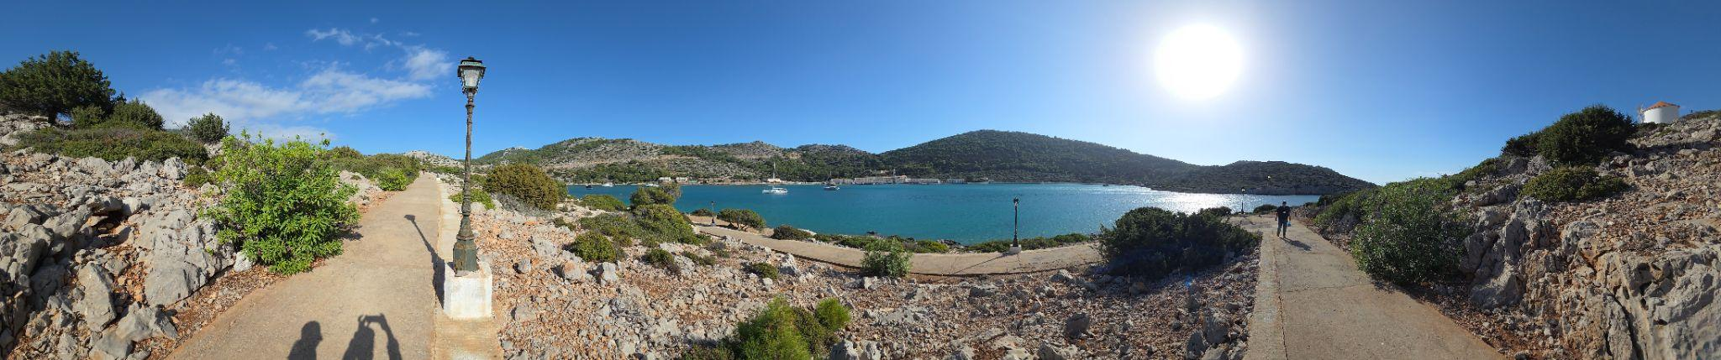
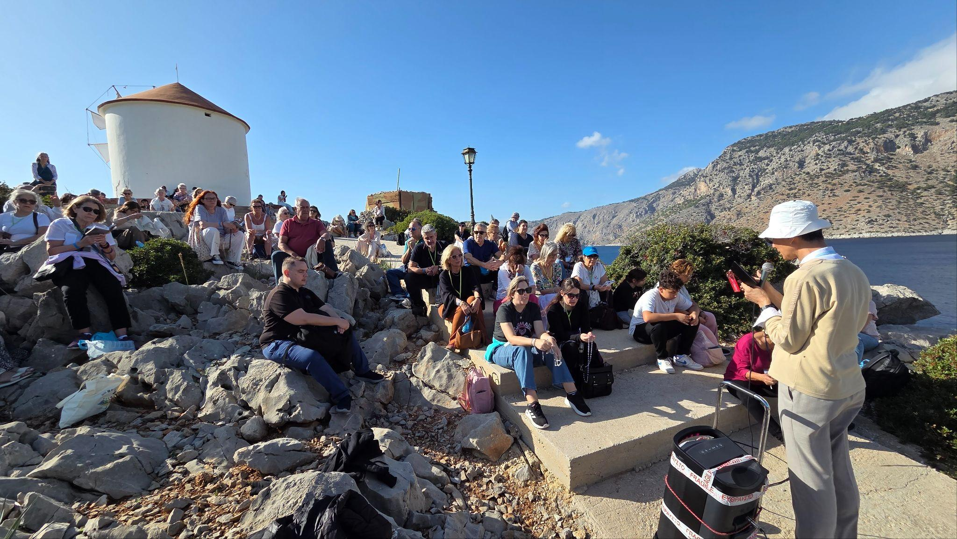
The walk to and praying the rosary at Mylos.
Day 5 Tuesday 28th October
Our morning commenced once more with singing the Our Father in Aramaic, immediately followed by the celebration of the Divine Liturgy of the Byzantine Rite with Fr Anwar El Khoury as the main celebrant and the homily by Fr Julio Gaddi.

The Divine Liturgy was followed by the 6th speech of the retreat presented by Fr Rolf Schonenberger. Fr Rolf’s speech addressed the fact that although there have been many women in the church who had a prophetic mission for the church of their time, none have had one to such an extent as Vassula. Her mission was entrusted by God to bring the entire church of Christ under one Shepherd. Father Rolf shared that this mission applies to these end times, whether one wants to hear it or not. He continued, as many of us know, that God desires to renew His entire church and the world. As God is the author of everything, He chose an instrument in Vassula that many in the church don't like. He put forward the defense that God is so different from us humans. Jesus often reminded Vassula in the messages of True life in God that He chooses who He wants. We know that He prepares very imperfect people for years for a specific task, that in turn, gives benefit to the church. Many people that listened were in awe with these stark yet true sentiments.

There was another powerful lay person’s testimony, which followed this final speech by clergy. Jack Matusiewicz from the USA held everyone’s attention in a way that all the previous testimonies had. Over the days of the retreat each of these testimonies were presented from different laity, with different contexts and circumstances, and yet all of them witnessed experiencing a deeper sense of God, a deeper understanding of Him and a desire to love and serve Him more. These were testimonies from people who shared how our Triune God who stooped down from heaven revealed Himself to those who did not seek Him, and who showed His Throne to those who had never honoured His Name. Yet now, it is these very ones who come to adore and worship Him; they have learnt from Your Spirit’s Mouth to proclaim praises to You (from the message of 28 December 1993).
After lunch on the last day of the retreat, we gathered onto our respective coaches that headed to the Monastery of Panagia Filerimos in Ialissos village on the opposite side of the island.
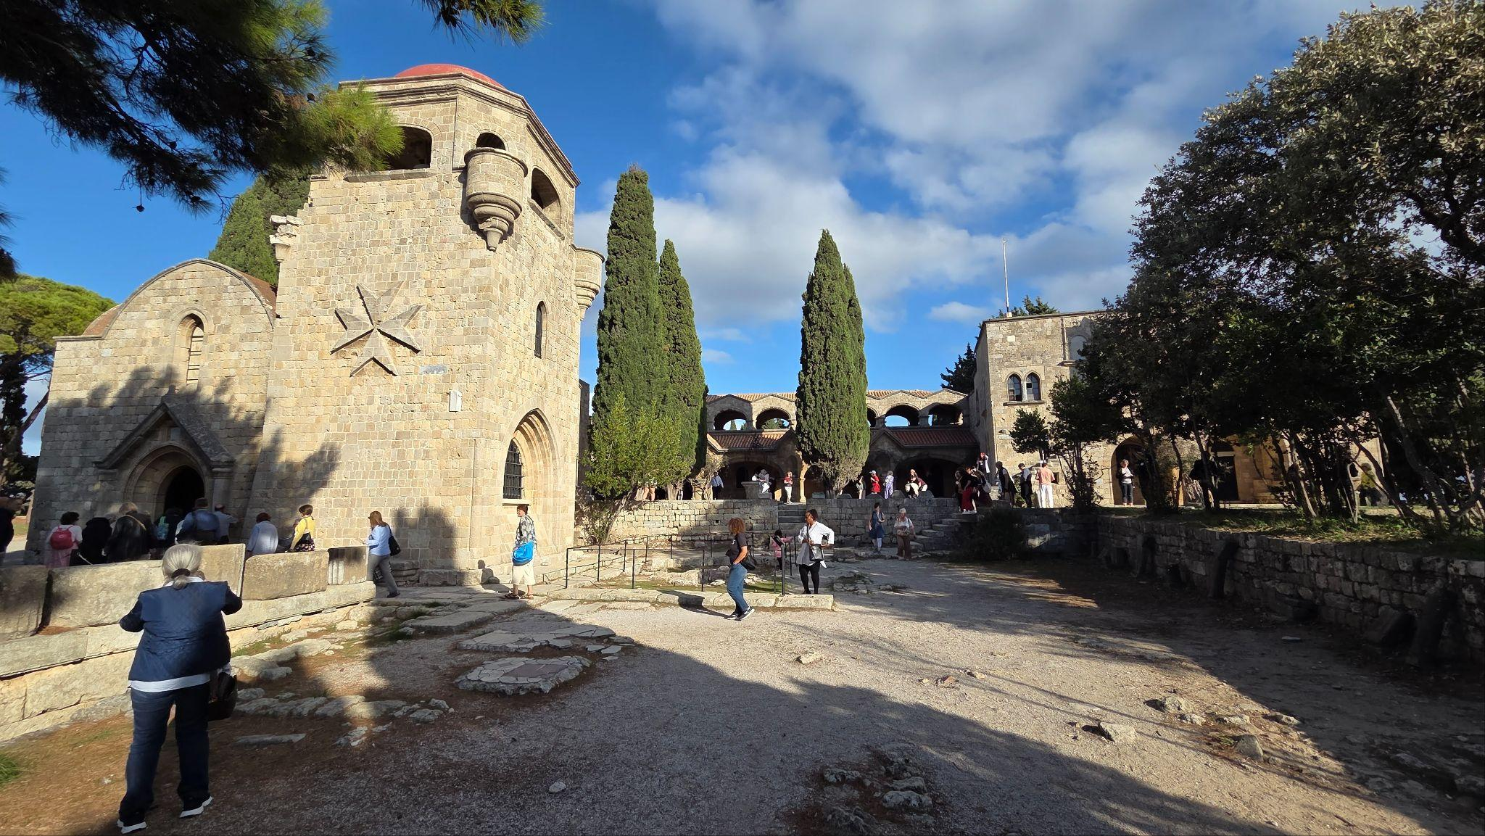
Monastery of Panagia Filerimos
The Monastery is located on a hill above Ialyssos, about 14 km from Rhodes town with a location that provides beautiful panoramic views over the Bay. The monastery itself is dedicated to the Virgin Mary and was constructed in the 15th century on the site of an older Byzantine monastery by the Knights of St John who had conquered the island at that time. The holy icon of the Virgin Mary was housed inside, which the Knights had probably brought to Rhodes from Jerusalem. When the Ottomans conquered the island in 1523, the Knights left and took the icon with them. The icon is now hosted in the National Museum of Montenegro. The monastery as it stands today was restored during the Italian rule of the island in the 20th century.
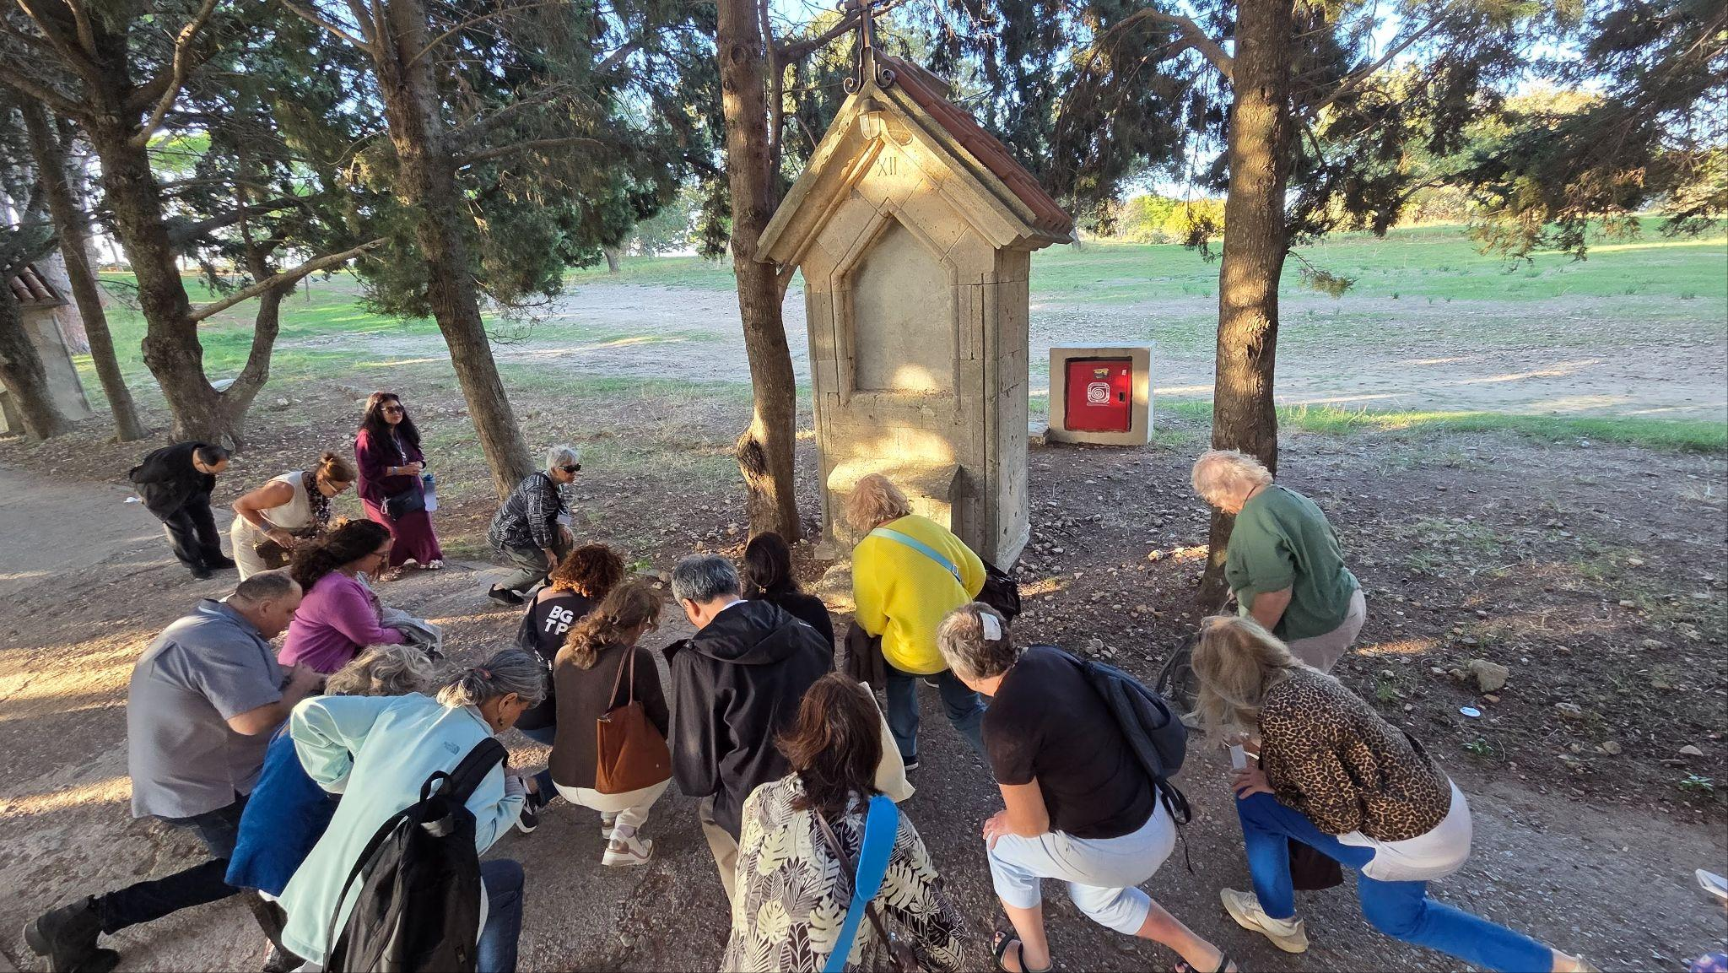
A group of retreatants praying the Stations of the cross at Filerimos
The ruins of a baptistery, in the shape of a cross, lie in the region around the monastery and are the remains of ancient Ialyssos, an underground church of Saint George that dates to the 14th century AD. The path to Golgotha also starts from Filerimos Monastery. On this path, up on a hill with an amazing view, a huge cross resides; while on one side of the path, there are the 14 stations of the cross representing the Passion of Jesus. We were all invited to do the stations of the cross at this spot. Although it had been reported that a couple of years ago, some people had removed the actual pictorial engravings from the actual stone representing the respective station, this did not impact as to how prayerful and solemn it was to pray the stations in this atmospheric monastery grounds with a soft sea breeze sweeping up from the bay. Peacocks roamed freely on the grounds too, and this reminded several of us of the peacocks that Vassula used to have in the garden of her house. It was such a peaceful afternoon interrupted only by the tooting of the bus horn to gather us back in the buses for a trip to Rhodes town for a free evening. We were driven to the old town of Rhodes where we enjoyed a few hours relaxing and taking in the atmosphere: watching the sun go down on an excellent day and an excellent retreat.
The retreat’s concluding activity was a raffle held to help raise funds for future TLIG events as well as the presentation of very powerful testimonies from five of the Greek people from local prayer groups in Rhodes and Athens. It was moving to hear of the closeness they had with Vassula. At times, some had even been present when she received messages, some messages specifically for those individuals present. Finally, we watched an extremely powerful video of Vassula taken from one of her previous witnessing events. Many people commented later that they had sensed Vassula’s presence through the use of the video and it gave each person commenting great peace and joy.

Participant Reflections
Retreat attendees expressed a profound sense of encouragement, spiritual renewal, and a deeper understanding of the prophetic dimension of the Christian life offered to us in abundance through the messages of True Life in God.
Many remarked on the inclusive and prayerful atmosphere which enabled honest sharing and collective discernment. So many, too, shared that they sensed a tangible love present and a sense that Vassula was very much with us every day of the retreat. The TLIG Greek association had done a marvellous job pulling the retreat together and then seeing the successful fruit of their hard labour. Many people from the Greek association work behind the scenes and are seldom recognised for the work that they do but without whom we would not have been able to enjoy this amazing retreat and in the joyful and comfortable way that we did. This report gives thanks to all those hands that worked so tirelessly together to allow us to come together in this way.

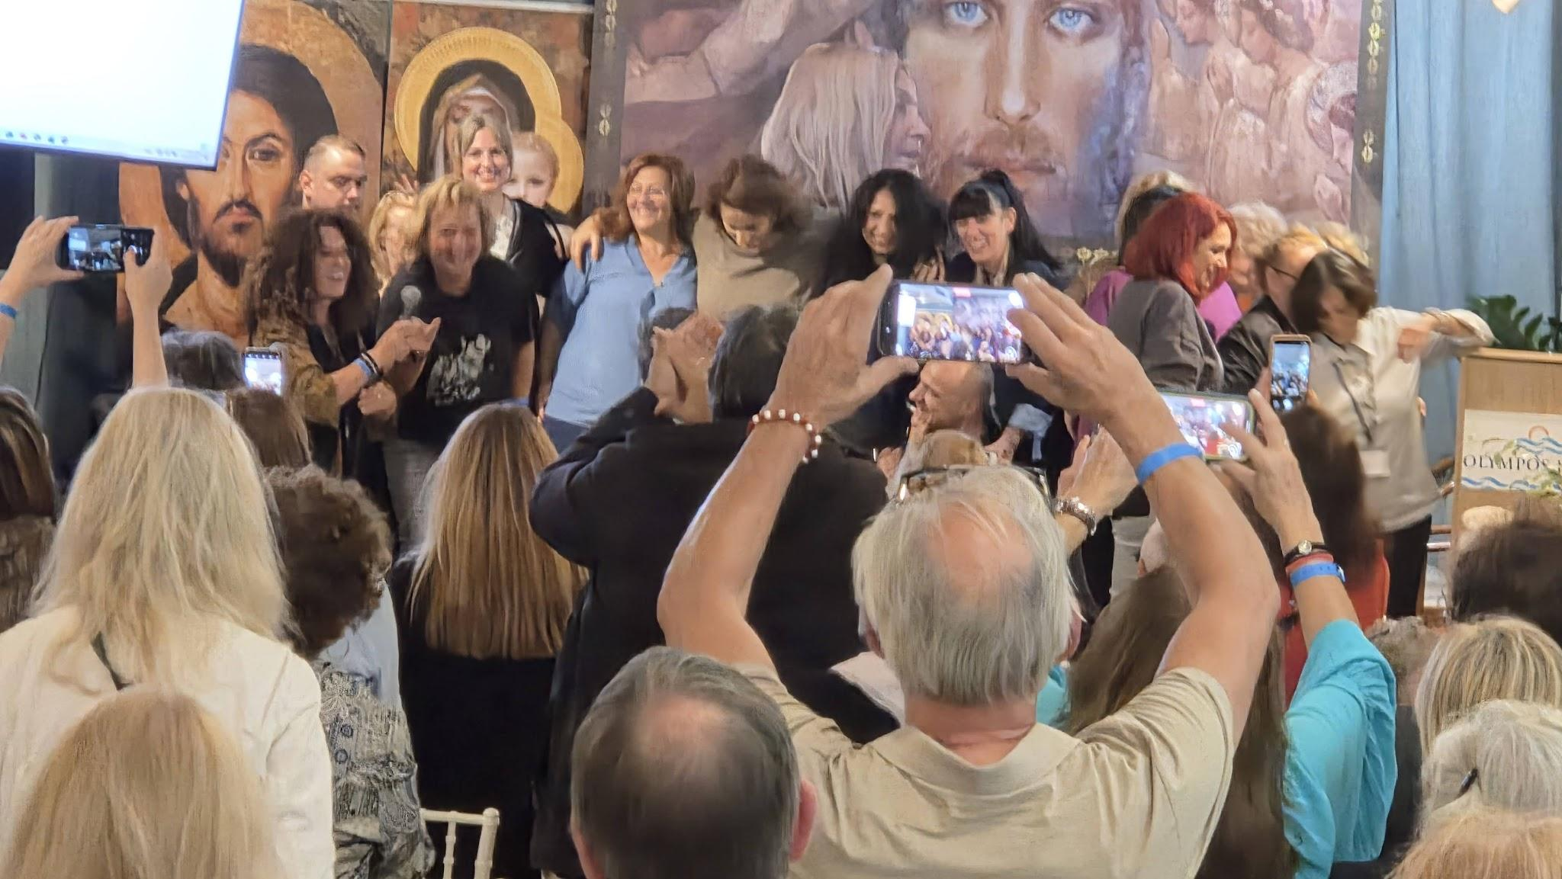
Several of the Greeks who volunteered to help make the retreat the success it was

Conclusion
The “Vassula – Prophet of the End Times” retreat served as a powerful reminder of the urgency of the Christian call to repentance, unity, and preparedness for the times ahead. It was a gathering of like-minded Christians whose desire is to unite the church and to continue with the legacy left by Vassula: a realisation of the call for all of us to be apostles of the end times. It served as a reminder of the words given by Jesus February 27, 1995:
“Lord, give us Your Kingdom, so that we may obtain incorruptibility and the deity to have eternal life; Amen;”
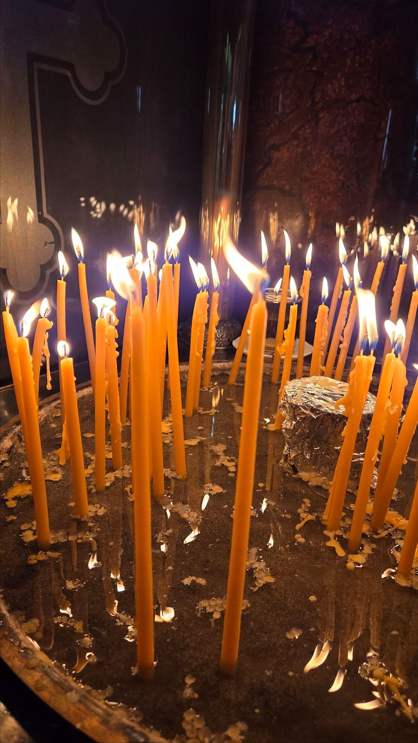

In his speech, Fr Anwar El Khoury concluded with an ecumenical blessing; it is fitting to conclude here with the blessing he gave:
✠ Ecumenical Blessing
“May this Jubilee Year unite all Christians — Catholic, Orthodox, and Protestant — in one song of praise and hope.
May Christ, our Living Jubilee, make us witnesses of mercy and pilgrims of peace in a world longing for His love.
Amen.

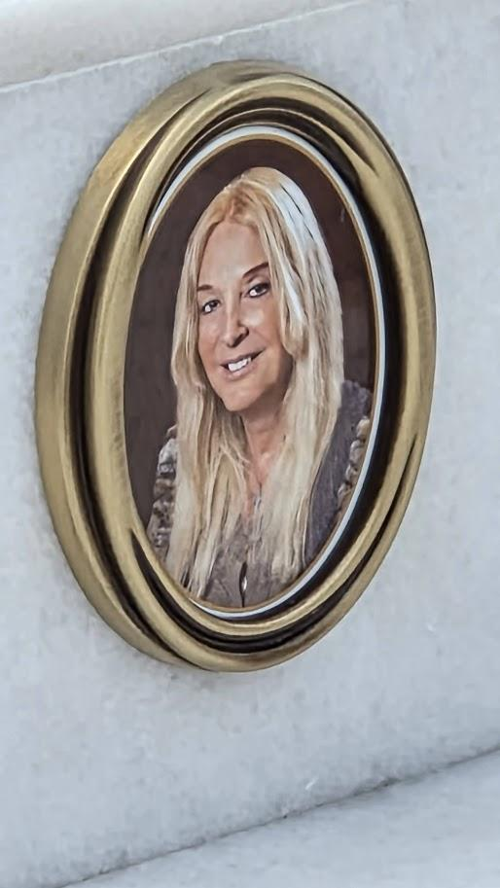
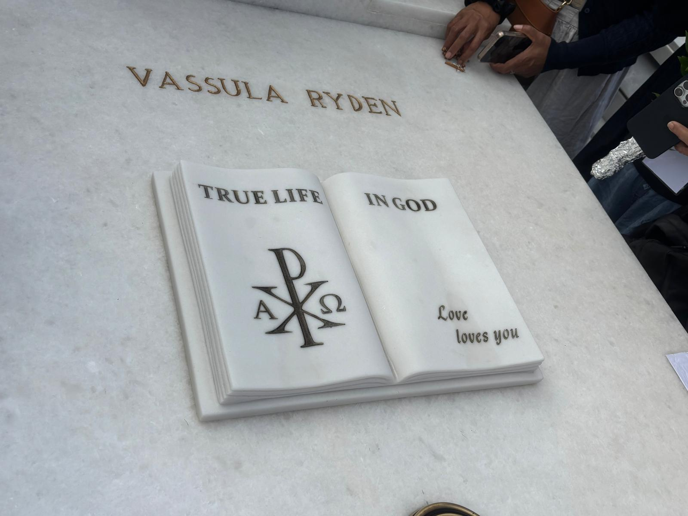
Carol Chamberlain, 21 November 2025

