A True Life in God Witness Talk for Christmas 2023
On Sunday, December 10th at 3:30 pm, in Chania, Crete, Theodora Konidari presented a witness talk in English, with Valia Zoppa interpreting into Greek, to an audience of 23 participants, all residents of Chania and its surrounding villages. As we neared Christmas, it was an especially good time to share the spirituality of True Life in God.
Doros from Athens TLIG designed a special website for the event which we can re-use with editing for future efforts. He also placed facebook and google ads. Thanasis, also from our Athens TLIG group, used the Greek TLIG facebook page to promote the event.
Flyers and invitations designed by Sophia-TLIG Athens were printed and distributed. The day before the talk, in rather cold weather, two other volunteers from Athens, Thalia and Marina, handed out almost 1000 invitations near the actual location where the talk would take place. We did have people come because of this effort. The Athens TLIG people worked together in a spirit of cooperation and selfless Christian love, and the event could not have happened without this selfless team work.
Theodora and Valia prepared for this talk with enthusiasm and dedication. Theodora chose to use some True Life in God Messages that brought to mind God’s Love for us, what this Love entails, and how we can find a relationship with Christ so that we can live in this Love.
Theodora firstly introduced us to her own journey towards God’s abounding love through her encounter, her reading, and contemplation of the True Life in God Messages. She spoke about the inception of these messages, given to Vassula Ryden from God. Theodora stated that without any preconceived notions or preparations, Vassula’s angel (Daniel) made her see how her sins were offending and saddening God, and she saw the sins as a film before her eyes. She saw her sins with God's eyes, and not as we see them. What a big difference. This was a grace because she really saw the gravity of her sins; God allowed her to feel her sins. Through this experience, she suddenly saw her true self, what she was really like, and she despised herself for having offended God so much. She wept when she saw her true self. For three weeks this went on. This is indeed an awakening message for all of us. Our wrong-doings affect God directly.
Theodora continued by saying that within the True Life in God Messages God asks us to take out the word Vassula when we read them; instead, we are asked to read them by adding in our own name because these messages are for all of us. They were given to Vassula for each of us personally, and for all of humanity. Therefore, by reading them, we discover what God wants from us, what we can do to please Him, and how we can live our lives in holiness, in His Sacred Heart. Theodora quoted a message where, Jesus says:
“Love Me more, but you cannot love Me unless you know Me. That is why you must approach Me in intimacy. I want your intimacy, but never forget that I am Holy.”
Theodora clarified, “So, what does this statement say about what God wants from us? He wants us to run to Him like a child, with simplicity of heart and speak to Him from our heart, as a child speaks to his Father (intimately), but with reverence respect, honoring Him and praising Him.” She furthered, saying that God sent His Son to earth to show us God’s essence, to have His son teach us how to live our lives with God. Jesus Christ’s birth reveals the Father’s loving character. Jesus Christ brings each of us to Him, to that intimate love, and from there we can serve God as He wants us to serve Him.
So, God wants us to get to know Him, because how can we love someone we don't know? Through the messages of True Life in God, Christ is shows us how much He is offended by our indifference to know and to love Him. We have even replaced His birth with non-important things, celebrating Christmas in the wrong way, forgetting the true significance of this day.
On the 24th December 1991, the eve of Christ’s birth, our Lord said:
“…today I come with peace-terms and a Message of Love, but the peace I am offering is blasphemed by the earth and the Love I am giving them is mocked and jeered in the Eve of My Birth; mankind is celebrating these days without My Holy Name; My Holy Name has been abolished and they take the day of My Birth as a great holiday of leisure, worshiping idols…I have warned the world…”
Towards the conclusion of her talk, Theodora led us back to Vassula’s first steps towards God: the steps we take to enable an encounter and relationship with Him. What is this first step we need to take? We must repent. Sincere repentance burns like fire in the soul, stated Theodora. Repentance allows the Holy Spirit to descend upon us to accomplish His divine work, tearing down all the dirt and imperfections that resist Him. To prepare us for this perfect union, He must purify us. When we repent with all our heart, we see our unworthiness through the eyes of our soul, and thus we become humble. Her call to action was: Let us think whether we have offended God and ask for His forgiveness.

In order to achieve this task towards complete repentance, God asks us for unceasing prayer. This is when one’s heart desires God and thirsts for Him all day long; it is a prayer without words. It is the silent prayer: A contemplative prayer. It manifests when one’s spirit is completely absorbed in God, and therefore becomes sensitive to His Presence. In those moments, one has no need for words to express oneself to God because one’s whole being is inflamed with love for God. There is no other higher endeavor worth achieving.
The participants received The Heaven is Real but so is Hell book as a Christmas gift. A survey was passed out, and the feedback we received was all positive. People verbally and in written form commented on the themes from Theodora’s talk that really penetrated them. This confirmed to us that her presentation was truly inspired by the Holy Spirit. Our hope is that a prayer group will form through the participants interest in the near future. For the organizers, this was truly a wonderful way to celebrate and prepare for Christmas.
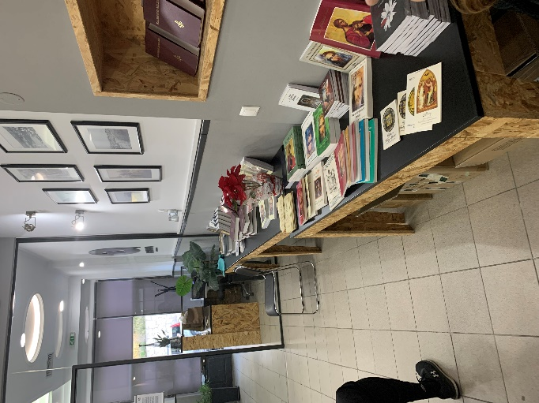
The Book Table
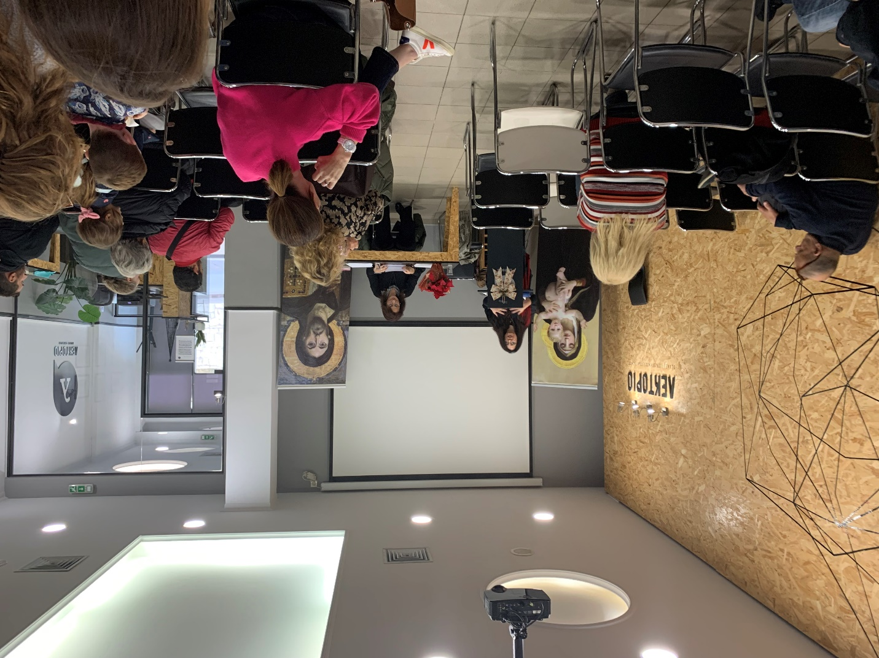
Theodora’s Talk
Written by-TLIG Volunteer Hosts: Maggie and Nektarios

