Our Creator ‘He who loves us most’ is calling... Will we listen?
Living in His Love

In gratitude for the remarkable testimony given by Valia and Theodora in Chania, Nektarios reciprocated the gesture by giving his testimony in Athens on April 20, 2024, with Catarina as his Greek translator. The title of his talk was: Our Creator ‘He who loves us most’ is calling... Will we listen?
Nektarios has been reading and studying the True Life in God Messages since 1997, and was baptized in 1998 by Vassula in Rhodes. When he began to read the True Life in God Messages, his desire to penetrate them led him to a deep repentance. Our Lord is no man’s debtor, and has given Nektarios not only a knowledge and understanding of his sins, but also a desire for God’s Wisdom. Hence, Nektarios’s breadth of understanding and prayerful acceptance for God’s word led him to travel with Vassula on her missions and present his testimony as a witness to various audiences. He has presented his testimony in Switzerland, Germany and in the USA: in Los Angeles, in Chicago, Wisconsin, Indiana, and Georgia, imparting concepts from the True Life in God Messages that inspired in his listeners a genuine desire and acceptance for God’s commands; in turn, finding a way to live in His Love.
It took some effort for Nektarios to construct a testimony for the Athenian audience. How does one impart the language of love, the desire God has to reach us, so we live with Him and for Him? Nektarios tried to capture the True Life in God Messages from various angles, asking the Holy Sprit to guide him. After quite a few revisions, Nektarios’s final account illustrated firstly that “Jesus, as the head of His Church, wants it stronger. He wants the Holy spirit to flow into it in greater force.” He introduced Vassula, presenting a video about her encounter with her Angel Daniel and God’s desire for her to receive His word, so as to spread it far and wide.
Nektrios summarized: “I can tell you the messages were sent by God to help us Find Him because so many have lost faith in God or their faith is weak. This means, that if you take the TLIG Messages to heart and work with them, a new sense of peace, purpose and meaning will grow in your heart; and this growth you will know in yourself as a divine blessing in your life.”
The Athenian hosts Theodora, Doros, Sophia, Thanasis, Marina, Thalia and all who helped them exerted much enthusiasm and energy towards inviting people to this presentation. Doros and Thansis worked online, Thanasis on facebook; Doros created a website and google ads. Sophia created a welcoming invitation that Marina and Thalia in-exhaustingly passed out to people, with the help of True Life in God friends. Theodora organized the event, reserving the venue, making the follow-up calls to the interested individuals, and creating evaluations, along with a True Life in God book display. She kept the organizational momentum going, listing the interested people, making sure the invitations were spread. May she and all the volunteers be blessed. A verbal invitation, thanks to Pavlo, was furthermore given via the True Life in God Radio. As a follow-up to the talk, a subsequent event was planned for the following day for those who wanted to hear more. It was a more intimate setting at a nearby café.
On the day of the talk, everything in the venue was set. Nektarios’s translator, Catarina, energetically, and with much love in heart translated Nektarios’s every word in the spirit and tone that he imparted. She echoed and complimented the whole of Nektarios’s presentation, enlivening the words in Greek as Nektarios did in English. Nektarios’s presentation, through the Holy Spirit’s grace, was full of life, encouragement, newness, and a clear depiction of our Lord’s calling through the True Life in God Messages. As his display, to illustrate his words, he used visuals, videos, and readable excerpts from the True Life in God Messages. He colorfully clarified the True Life in God themes through personal anecdotes, historical accounts, stories, and a call to personalize God’s calling. Overall, the presentation was animated.
There were sixty members in the audience, thirteen newly interested in the TLIG messages and four that attended the café gathering the following day. Everyone took a Heaven is Real and/or the TLIG Book One. Picturesque cards and calendars were also freely given. The witness talk was a success, Thanks Be to God Almighty!
Nektarios ended his talk with this True Life in God passage:
I, the Lord, love all of you and it is for the sake of those who seek The Truth that I come to show them again what The Truth really is and what It means since they have forgotten It; I am The Truth and The Truth is Love, Fathomless Love, Sublime Love, Eternal Love; My Book is a Book of Love; (TLIG Messages, April 9, 1988)
Written by-TLIG Volunteer: Magdalini

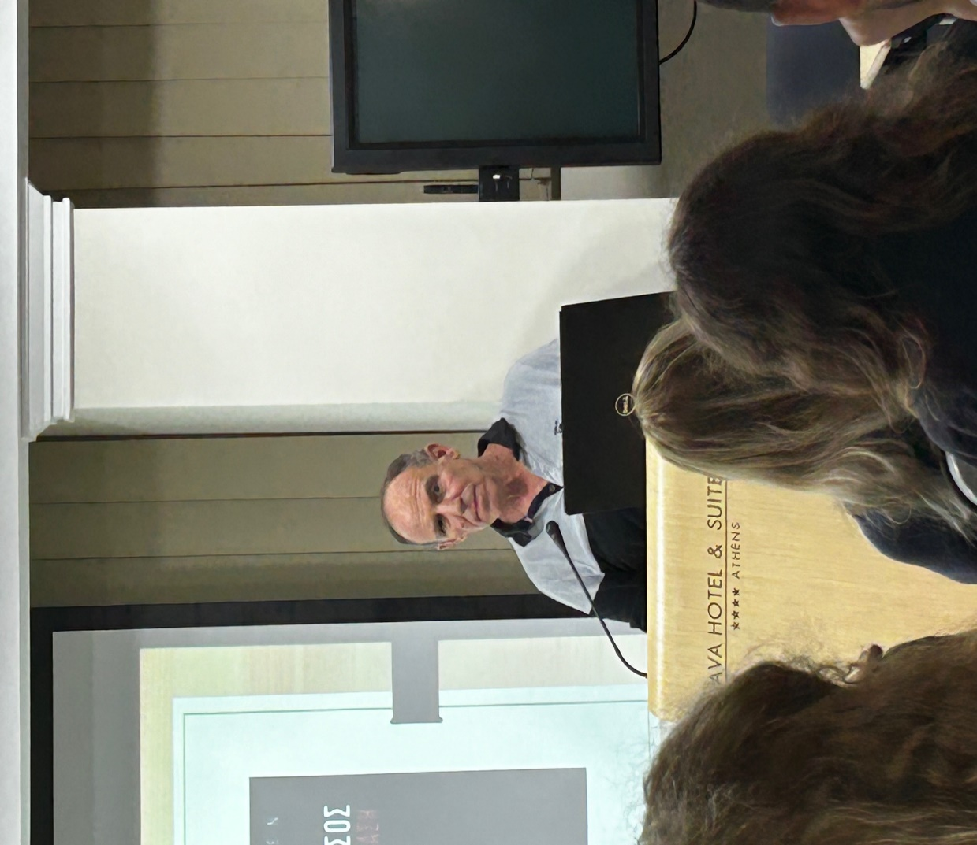
Nektarios at the Podium
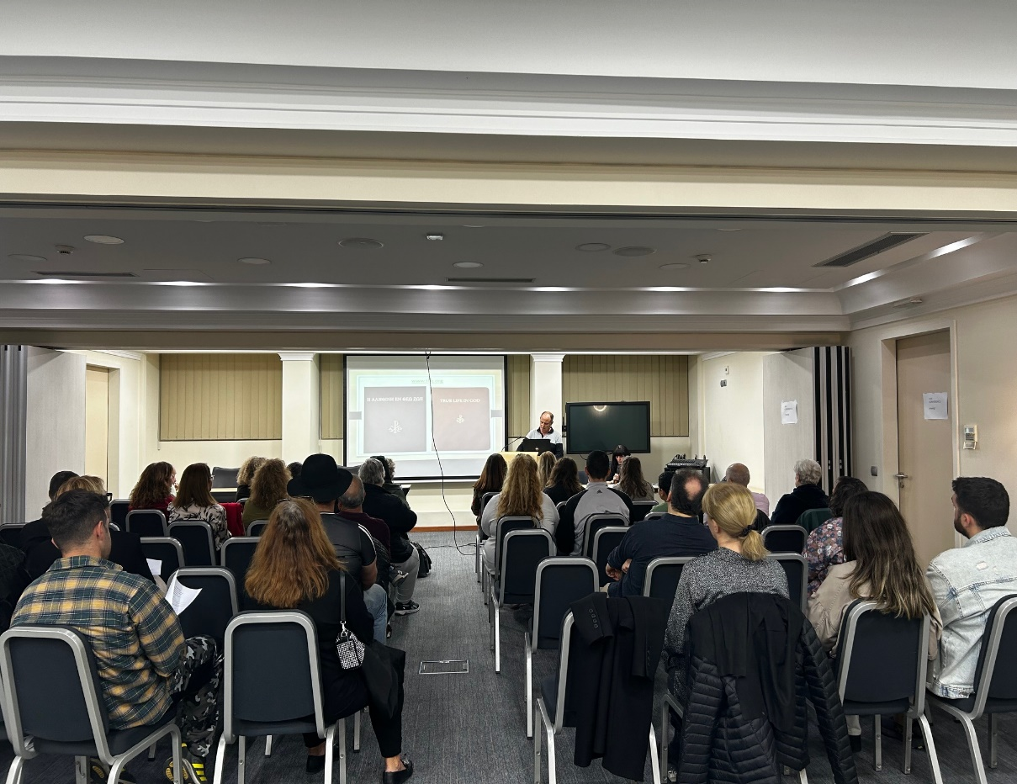
The Audience

